Module A
Experience Through Language
Elective B: Distinctively Visual
Prose fiction: Lawson, Henry -`The Drover's Wife', `The Bush Undertaker', `In a Dry Season', `The Loaded Dog'

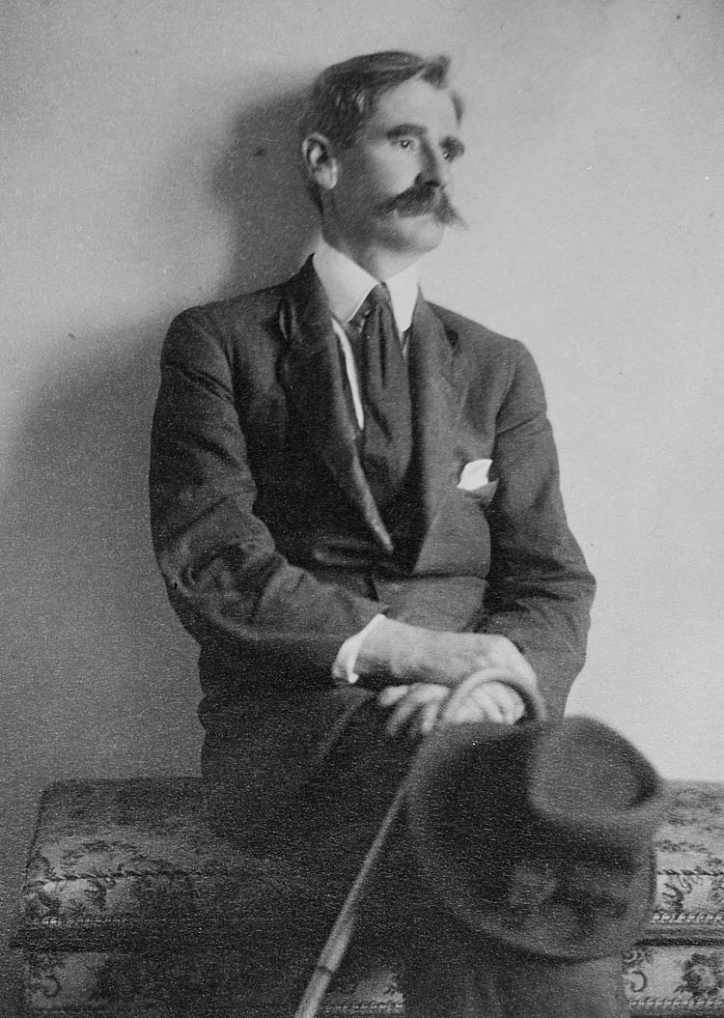

2017 Year 12 Resource Booklet

Student Resource Booklet
Table of Contents
Resource | Page #

Introduction to Module A Experience Through Language  Elective B Distinctively Visual | Pg. 3
Breaking Up the Module | Pg. 4-5
Related Text #1- Richard Thomas ‘The Worker’ poem | Pg. 6-7
Related Text #2- “The Water Diviner” film extract | Pg. 8
Related Text #3- Nick Ut ‘Terror of War’- Photograph | Pg. 9-13
Context- Henry Lawson | Pg. 14
Timeline of Lawson’s Life | Pg. 15
Lawson’s Stories and Style | Pg. 16
Prescribed Text #1- ‘The Drovers Wife’ | Pg. 17- 22
Prescribed Text #2- ‘The Bush Undertaker’ | Pg. 23- 29
Prescribed Text # 3- ‘In a Dry Season’  Prescribed Text #4- ‘The Loaded Dog’  Past HSC Questions  Practice Essay Question and table scaffold  Sample A-Range Responses  Preparing for your Half-Yearly Examination | Pg. 30- 35  Pg. 36- 41  Pg. 42  Pg. 43- 51  Pg. 52-67  Pg. 68- 74

Introduction to Module A

Module A: Experience Through Language

This module requires students to explore the uses of a particular aspect of language. It develops students’ awareness of language and helps them to understand how our perceptions of and relationships with others and the world are shaped in written, spoken and visual language.

Each elective in this module requires study of a prescribed text through a key aspect of language. This provides the basis for the study and use of this aspect of language in other texts, including texts drawn from students’ own experience.

Students examine particular language structures and features used in the prescribed text and in a range of situations that they encounter in their daily lives. They explore, examine and analyse how the conventions of textual forms, language modes and media shape meaning. Composition focuses on experimentation with variations of purpose, audience and form to achieve different effects. These compositions may be realised in a variety of forms and media.

Elective 2: Distinctively Visual
In their responding and composing, students explore the ways the images we see and/or visualise in texts are created. Students consider how the forms, features and language of different texts create these images, affect interpretation and shape meaning. Students examine one prescribed text, in addition to other related texts of their own choosing that provide examples of the distinctively visual.

Activities:
1. Highlight/underline the key words from the syllabus.
2. Write in your own words what you believe the syllabus is asking of you.

Breaking up The Module
What does ‘distinctively’ mean?
- Distinguishing characteristics
- Something which serves as a mark of difference/separation-Peculiarity/ individuality
- Particularly noticeable
- Prominent
- Something which is typically classed as separate
- Strong enough, large enough, or definite enough to be noticed
- Unique

What does visual refer to?
- Something perceptible by sight (vision) or by the mind (perception)
- Able or intended to be seen by the eyes or be perceived as a picture in the mind
Defining Distinctively Visual
In the context of the rubric:
- Anything WITHIN THAT TEXT that provokes an image that you can physically see or imagine.
- It provokes an image WITHIN THAT TEXT which is connected to a CLEAR attitude/value/ perspective/idea.

Defining Image
- An actual or mental picture. Produced either physically by a sculptor, painter, or photographer, or formed in the mind by auditory, written, or visual means
- A very typical or extreme example of something e.g. the very image of evil, greed, beauty
- A person or thing bearing a close likeness to somebody or something else. e.g. She’s the image of her father
- Image is the idea behind what you see/visualise.

What provokes images?
Written Text: | Visual Text:
- Figurative Language  - Descriptive language  - Imagery  - Word choice (Emotive language)  - Recount  - Narrative structure  - Repetition of words and images  - Adjectives  - Verbs  - Punctuation –bold capital letters, ellipsis (….) , exclamations to show emotion (!), font.  - Direct speech / dialogue –where quotation marks are used (“ ”). When we hear someone speaking it makes the text more engaging and authentic as we can visualise the scene  - Compound words –connecting words to make the description more powerful e.g. sun-drenched, mud-splattered  - Formal language, informal language, colloquial language, slang to create authentic characters | - Colour  - Framing-included/ omitted?  - Composition  - Character and object positioning  - Body Language, facial expressions, posture, gestures, hairstyle, clothing, etc  - Vectors-Focus/Placement  - Lighting  - Shot type, angle & distance  - Symbolism /icons (setting, object, costume, make up)  - Absence of written text  - Subject choice-Who? What? Where? What?

What is the function of images?
- TO: Provoke, Confirm, Inform
- The function of an image could be to express ideas about:
- Characters (confident, submissive, determined)
- Relationships (animosity, friendship)
- The World-themes/views/ perceptions (horror of war, power of friendship etc.)

Analysing Distinctively Visual Texts
Step 1: Identify what you see

Step 2: What ideas are revealed by the image?
-Character (people)
-Relationships
-The World (place, event, perceptions, views)

Step 3: How are these images conveyed? TECHNIQUES

Related Text # 1- Richard Thomas ‘The Worker’- Poem

My father lies black and hushed
Beneath white hospital sheets
He collapsed at work
His iron left him
Slow and quiet he sank

Meeting the wet concrete floor on his way
The wheels were still turning--they couldn't stop
Red and yellow lights flashing
Gloved hands twisting knobs--they couldn't stop
And as they carried him out
The whirring and buzzing and humming machines
Applauded him
Lapping up his dripping iron

They couldn't stop.

Techniques to focus on:
-visual imagery
-kinetic imagery
-auditory imagery
-tactile imagery
-repetition

This poem by Richard W. Thomas is almost entirely image-based. Thomas uses visual, kinetic, auditory, and tactile images to help illustrate his poem.

Questions:

- Describe what is happening in this poem.
- Find the visual images used in the poem. Find at least one quote from the text and describe the image that you see as a result.
- Find the auditory images used in this poem. Quote the lines that build this auditory image and then explain the sound being described in your own words.
- Find the line that uses a tactile reference i.e refers to the sense of touch and quote this line. Quote these lines and explain the tactile sensation they describe in your own words.
- The poet also creates kinetic images i.e. images that help us to visualise movement. Quote these lines and explain the movement being described in your own words. How has the composer used repetition? Why has the composer used repetition?
- The poet is helping us to perceive the death of his father due to an industrial accident. The images employed tell us a lot not only about the father's death but also about the poet's relationship with his father and his feelings about his death. What do you think the poet is saying?
- What are the distinct images that you see within the poem?
- Write at least ONE concept statement which links to the poem.
- Construct a body paragraph that addresses ONE concept statement written in question 8. Ensure you follow the TEEEL structure.
- T- Topic Sentence
- E- Explain/Expand
- E- Examples and technique/s
- E-Evaluate
- L- Link

Related Text #2- Film Extract “The Water Diviner” 2014- Dust Storm
The syllabus description of Module A, which requires you to study how language techniques create an image, refers not only to written language and spoken word, but also the study of visual language techniques.
After viewing the extract answer the following questions:
Dust Storm: https://www.youtube.com/watch?v=aCjchkyE-YA
- How does this clip present the Australian landscape? (Prepare a topic sentence to answer this question - The Australian landscape is presented as...)
- How have cinematic features/visual techniques been used to highlight this depiction of the Australian landscape? Complete the following table.
Techniques | Specific examples from text and what these tell us about the Australian landscape.
Camera angles
Long shots, POV, Close up etc
Camera movement
Panning, Tracking etc
Diegetic and non-diegetic sound
Lighting
Low-key lighting and high-key lighting
- What are the distinct images that you see within the extract?
- Write at least ONE concept statement which links to the film extract.
- Construct a body paragraph that addresses ONE concept statement written in question 4. Ensure you follow the TEEEL structure.
- T- Topic Sentence
- E- Explain/Expand
- E- Examples and technique/s
- E-Evaluate
- L- Link

Related Text #3- Nick Ut ‘Terror of War’/ ‘Napalm Girl’- Photograph 1972

The “Terror of War” photo was taken by photographer Nick Ut on June 8, 1972, near Trang Bang in South Vietnam. The photo shows children fleeing in terror, with the focus on nine-year-old Phan Thi Kim Phuc, in the center, who ripped off her burning clothes after she was splashed by napalm. There was a brief editorial debate about whether to print a photo involving nudity, but it was subsequently published all over the world the next day.
Nick Ut's photo was an extremely powerful and influential image as:
  - it helped turn U.S. public opinion against America's ongoing involvement in the Vietnam War
  - it contradicted U.S. propaganda that America was helping the South Vietnamese people and was not an aggressor

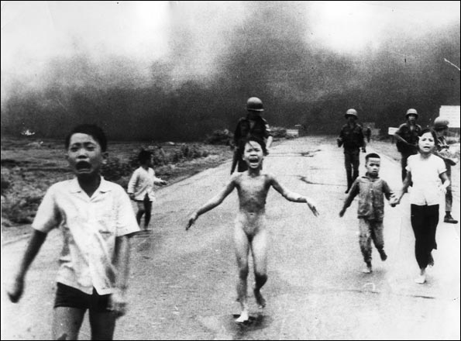

The 1972 photograph of nine year old South Vietnamese girl, Kim Phuc, fleeing her village of Trang Bang after a napalm attack won the Canadian photographer, Nick Ut, a Pulitzer prize and is one of the iconic images that helped turn US public opinion against US involvement in the war. The photograph shows a group of terrorised South Vietnammese children running down the road away from their burning village, being followed casually by several South Vietnamese soldiers who appear to be casually indifferent to the children’s suffering.
For years the US public had been fed propaganda that US forces were in Vietnam to help the South Vietnamese fight off the threat from the Communist north. This photograph suggests the propaganda was a lie; it shows the South Vietnamese people being dispossessed and horribly injured by the US/South Vietnamese war machine, victims of collateral damage.
Although not staged, this photograph was carefully selected from thousands of others as the text features of this image have the ability to sway the opinion of the responder regarding U.S. involvement in the Vietnam war. The fact that the subjects are young children prevents the responder from dismissing the image by saying they were probably Viet Cong and therefore deserved their fate; the children are too young to be guilty of anything. The terrified expressions on the children’s faces suggests that the US war effort was terrorising the South Vietnamese people not helping them. The fact that the central figure of the photograph is naked symbolised the concept that the US war effort is stripping people of their dignity while the casual attitude of the soldiers who follow the children without trying to assist them portrays the US/South Vietnamese war personnel as callous and uncaring about the suffering they inflict on the South Vietnamese people. The smoke of the burning village in the background suggests that the children have been deprived of their home by US/South Vietnamese war effort whilst the absence of Vietnamese civilian adults in the photograph suggests that they have had their parents taken from them as well.
This text demonstrates the power of images to shape public opinion through the careful selection and/or manipulation of text features.

Consider the following:
- It has been claimed that the young, female, naked figure represents the victimized, feminized country of Vietnam.
- There is a stark contrast between the soldiers and the children, the soldiers’ business as usual attitude contrasts with the girl’s pain and terror. The soldiers show that this seemingly rare event is not all that uncommon. The soldiers are supposed to be protecting the children, but they are merely herding them down the road.
- Pain is the central frame of the photo. The photograph projects her pain into our world.
- The child that is closest to the camera, in the foreground, has a look of terror on his face, resembling Eduard Munch’s famous drawing of “The Scream.”
- Her nudity represents innocence, an innocence that has been taken away from her by the war.
- The children are running right at the camera, creating an intensity and haste.
- The photographer who took the photo was taller than the children, therefore shooting from above the subjects and deeming them powerless.
- The boy who is in the foreground of the photo has a look of terror on his face. He is also closest to the camera of all of the characters so the viewer is more emotionally connected to him.
- The soldiers behind the children appear to be herding the children, moving them along away from the danger. The authority of the soldiers over the children raises questions about their parents. Where are their parents? Were they killed in the fighting? Are these orphans?
- The soldiers’ actions create a notion that they are herding the children, and that the Vietnamese are animals that need to be tamed and controlled by the Americans. In the background of the photo, the smoke from the fire can be seen. The dark smoke represents the dark, ominous, and dangerous situation that is occurring in Vietnam.

Uncropped Version of The Image

Although the photograph was not staged (as President Richard Nixon privately suggested at the time of its publication), the uncropped version clearly demonstrates how images can be made more powerful when publishers have a good understanding of how they work and publish them to maximise their impact. The uncropped version clearly shows press photographers being as callous as the American soldiers.

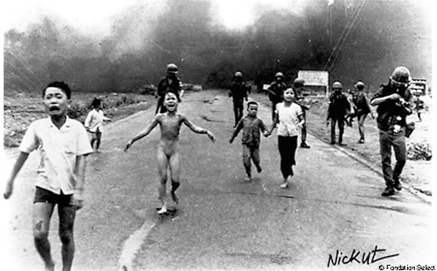

Techniques to consider:
Salient Point
Foreground
Background
High Angle Shot
Appropriation

Activities:
- Identify the salient point in the cropped image. What is the effect of this?
- Who are in the foreground? What is the effect of this? What does it tell you about who holds the power?
- Who are in the background? What is the effect of this? What does it tell you about who holds the power?
- What is the effect of the slight high angle shot?
- Which famous artwork does the young naked girl appropriate?
- What is the effect of cropping the original image?
- What are the distinct images that you see within the photograph?
- Write at least ONE concept statement which links to the image.
- Construct a body paragraph that addresses ONE concept statement written in question 8. Ensure you follow the TEEEL structure.
- T- Topic Sentence
- E- Explain/Expand
- E- Examples and techniques
- E-Evaluate
- L- Link

The Terror of War/Napalm Girl IEEL Table
Topic Sentence (T) | Explain/Expand (E) | Examples and techniques (E) | Evaluate (E) | Link back to topic sentence or question (L)

Sample essay segment for Napalm girl
The 1972 photograph of the nine year old South Vietnamese girl, Kim Phuc, fleeing her village of Trang Bang after a napalm attack won the Canadian photographer, Nick Ut, a Pulitzer prize and is one of the iconic images that helped turn US public opinion against US involvement in the war. The photograph shows a group of terrorised South Vietnamese children running down the road away from their burning village, being followed casually by several South Vietnamese soldiers who appear to be casually indifferent to the children’s suffering.

For years the US public had been fed propaganda that US forces were in Vietnam to help the South Vietnamese fight off the threat from the Communist north. This photograph suggests the propaganda was a lie; it shows the South Vietnamese people being dispossessed and horribly injured by the US/South Vietnamese war machine, victims of collateral damage.

Although not staged, this photograph was carefully selected from thousands of others as the text features of this image have the ability to sway the opinion of the responder regarding U.S. involvement in the Vietnam war. The fact that the subjects are young children prevents the responder from dismissing the image by saying they were probably Viet Cong and therefore deserved their fate; the children are too young to be guilty of anything. The terrified expressions on the children’s faces suggests that the US war effort was terrorising the South Vietnamese people not helping them. The fact that the central figure of the photograph is naked symbolised the concept that the US war effort is stripping the South Vietnamese people of their dignity while the casual attitude of the soldiers who follow the children without trying to assist them portrays the US/South Vietnamese war personnel as callous and uncaring about the suffering they inflict on the South Vietnamese people. The smoke of the burning village in the background suggests that the children have been deprived of their home by the US/South Vietnamese war effort whilst the absence of Vietnamese civilian adults in the photograph suggests that they have had their parents taken from them as well.

This text demonstrates the power of visual images to shape public opinion through the careful selection and/or manipulation of text features

Context- Henry Lawson

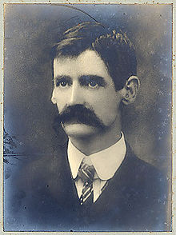
Henry Lawson was an Australian writer and poet. Along with his contemporary Banjo Paterson, Lawson is among the best-known Australian poets and fiction writers of the colonial period and is often called Australia's "greatest writer". He was the son of the poet, publisher and feminist Louisa Lawson.

Henry Lawson was born in a town on the Grenfell goldfields of New South Wales. His father was Niels Herzberg Larsen, a Norwegian-born miner who went to sea at 21, arrived in Melbourne in 1855 to join the gold rush. Lawson's parents met at the goldfields and married on 7 July 1866; he was 32 and she, 18.

Henry Lawson attended school from 2 October 1876 but suffered an ear infection around this time. It left him with partial deafness and by the age of fourteen he had lost his hearing entirely. He later attended a Catholic school at Mudgee, New South Wales around 8 km away; the master there, Mr. Kevan, would teach Lawson about poetry. Reading became a major source of his education because, due to his deafness, he had trouble learning in the classroom.

In 1883, after working on building jobs with his father and in the Blue Mountains, Lawson joined his mother in Sydney at her request. At this time, Lawson was working during the day and studying at night in the hopes of receiving a university education. However, he failed his exams. In 1896, he married Bertha Bredt Jr., daughter of a prominent socialist. They had two children, son Jim (Joseph) and daughter Bertha. However, the marriage ended unhappily.

Lawson's first published poem was 'A Song of the Republic' which appeared in The Bulletin, 1 October 1887. In 1892 The Bulletin paid for an inland trip where he experiences the harsh realities of drought-affected New South Wales. This became a source for many of his stories in subsequent years. The trek Lawson took between Hungerford and Bourke was one of the most important treks in Australian literary history and it confirmed all of his prejudices about the Australian bush.

Lawson uses short, sharp sentences, with language as raw as Ernest Hemingway or Raymond Carver. With sparse adjectives and honed-to-the-bone description, Lawson created a style and defined Australians as people of few words, passionately egalitarian and deeply humane.

Like the majority of Australians, Lawson lived in a city, but had had plenty of experience in outback life, in fact, many of his stories reflected his experiences in real life. Despite his position as the most celebrated Australian writer of the time, Lawson was deeply depressed and continually poor. He lacked money due to deals with publishers and his ex-wife repeatedly reported him for non-payment of child maintenance, resulting in gaol terms. He was gaoled at Darlinghurst Gaol for drunkenness and non-payment of alimony, and recorded his experience in the haunting poem "One Hundred and Three" - his prison number - which was published in 1908. At this time, Lawson became withdrawn, alcoholic, and unable to carry on the usual routine of life.

Lawson died in Sydney in 1922 and was given a state funeral. His funeral was attended by the Prime Minister W. M. Hughes and the Premier of New South Wales Jack Lang, as well as thousands of citizens. Lawson was the first person to be granted a state funeral.

Timeline of Lawson’s Life
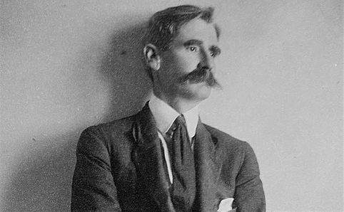
-1867 Born 17 June at Grenfell, NSW to father Niels Larsen, Norwegian sailor-turned-digger, and Australian-born Louisa (born Albury)
-1868 Parents move to New Pipeclay (later Eurunderee), near Mudgee
-1871 Family moves to goldfields at Gulgong
-1873 Lawsons return to Pipeclay
-1875-79 Attends school at Eurunderee, Pipeclay Creek and Mudgee
-1880-83 Goes to work with father, now a carpenter
-1883 Moves to Sydney to be with his mother – parents separated
-1884-87 Apprenticed as a coach painter
-1887-88 Lawson's mother publishes political paper The Republican, Lawson contributes to it and to The Bulletin; visits Melbourne and Ballarat
-1888-90 Lawson contributes to Town and Country Journal, Freeman's Journal and Truth; travels to Albany, WA for five months
-1891 On staff at The Boomerang, a Brisbane weekly
-1892-93 Travels to Bourke; writes for The Western Herald and sends work to The Bulletin; works as a house painter in Bourke and a rouseabout at Toorale station; walks to Hungerford, on Queensland border, and back
-1893 Travels to New Zealand
-1894 Returns to Sydney; works for papers Daily Worker and Worker; first book - Short Stories in Prose and Verse - published by his mother
-1895 Meets his future wife, Bertha Bredt
-1896 In the Days When the World Was Wide published; marries Bertha Bredt, 18; travels to Perth; While the Billy Boils published
-1897 Moves to New Zealand
-1898 Son Joseph Henry born; returns to Sydney
-1899-1900 On the Track and Over the Sliprails and Verses Popular and Humorous published; daughter Bertha Marie Louise born; moves to England
-1901 The Country I Come From and Joe Wilson and His Mates published
-1902 Children of the Bush published; returns to Australia
-1903 Separates from Bertha; lives a vagrant's life in Sydney
-1904 Taken in by Isabel Byers, who will care for him for many of his remaining years
-1905 Jailed for not paying maintenance; When I Was King and Other Versespublished
-1906 Sells copyright of Children of the Bush to Angus & Robertson
-1908-09 First of a series of confinements in Darlinghurst Mental Hospital; jailed for defaulting on maintenance
-1910 The Rising of the Court and The Skyline Riders and Other Versespublished
-1911 Again admitted to mental hospital; A Coronation Ode and Retrospectpublished
-1912-13 Living as an alcoholic vagabond in Sydney
-1914 Twice visits childhood area of Mudgee/Eurunderee
-1915 My Army, O My Army published; moves to Murrumbidgee Irrigation Area, NSW
-1918-19 Partly sustained by an allowance from his publishers but often seen with his hat out at Circular Quay
-1920 Lawson's mother dies in Gladesville Mental Hospital
-1921 Three months in hospital after a cerebral haemorrhage
-1922 Dies on 2 September at Abbotsford, Sydney, aged 55; given state funeral and buried at Waverley Cemetery.

Question:
Which events do believe would have affected Lawson’s writing the most? Why?

Lawson’s Stories and Style

The short stories set for study were written by Henry Lawson during the 1890s. By this time, Australia (although not yet federated), had been settled for over one hundred years. This makes Henry Lawson one of the first Australian born writers with compositions influenced by the unique Australian landscape and emerging culture. For this reason, Lawson contributed significantly to the creation of a recognisable Australian identity.
By the late 1800s, most Australians lived in towns and cities, however it was the Australian bush that captured their imagination. This, perhaps, was due to the harsh and rugged bush environment, which was very much in contrast to the mild rose gardens and green pastoral areas of the English landscape; a landscape firmly fixed in the minds of a predominantly British population.
Lawson wrote primarily for The Bulletin – a publication known as the ‘bushman’s bible’ because of its appeal to the characteristics and beliefs of men in the 19th Century: mateship, egalitarianism, unionism and occasionally socialism and republicanism.
The Sketch
Lawson often wrote in a style known as the ‘sketch’. A sketch is a short story with very little plot. As the name suggests, the focus is on ‘sketching’; similar to an artist, the writer creates impressions of people and places – a picture in words. The most notable examples of ‘sketches’ in the selection set for study are The Drover’s Wife and In a Dry Season.
This style is more serious in nature and is often an attempt to show the tragedy in people’s lives for its own sake. For this reason, the ‘sketch’ lends itself to powerful observations concerning the human condition. In fact, the responder becomes a voyeur watching as the sketch unfolds and reveals itself. Lawson himself said "I thought the short story was a lazy man's game, second to 'free' verse, compared with the sketch. The sketch, to be really good, must be good in every line. But the sketch- story is best of all."2 Here, Lawson admits to combining two distinct writing styles – the sketch and the short story. This blending of styles explains the tightly structured nature of his short stories and his tendency to focus on characterisation and setting over plot in creating a distinctively visual impression of life in the Australian bush.

Prescribed Text #1-‘The Drovers Wife’- Short Story

As the title suggests, this story is about a drover’s wife; a woman who is continually left to look after the house and children whilst her husband is away for long periods droving sheep or cattle. As she is left alone, the drover’s wife must deal with the many hardships of living in the bush – a harsh and unforgiving environment.
The main complication of the story is the presence of a snake, which threatens the safety of her children. The drover’s wife must wait patiently all night for the snake to come out from under the house so that she can kill it, thus protecting her family.

Purpose
Henry Lawson’s purpose in writing this story lies in his role as the ‘voice of the bush’ and his assault on Australian writers writing in the Romantic tradition – namely Banjo Paterson. In The Drover’s Wife, Lawson confronts his readers with the harsh realities of life in the Australian outback, whilst also forcing them to reconsider their perception of the role of women.

Audience
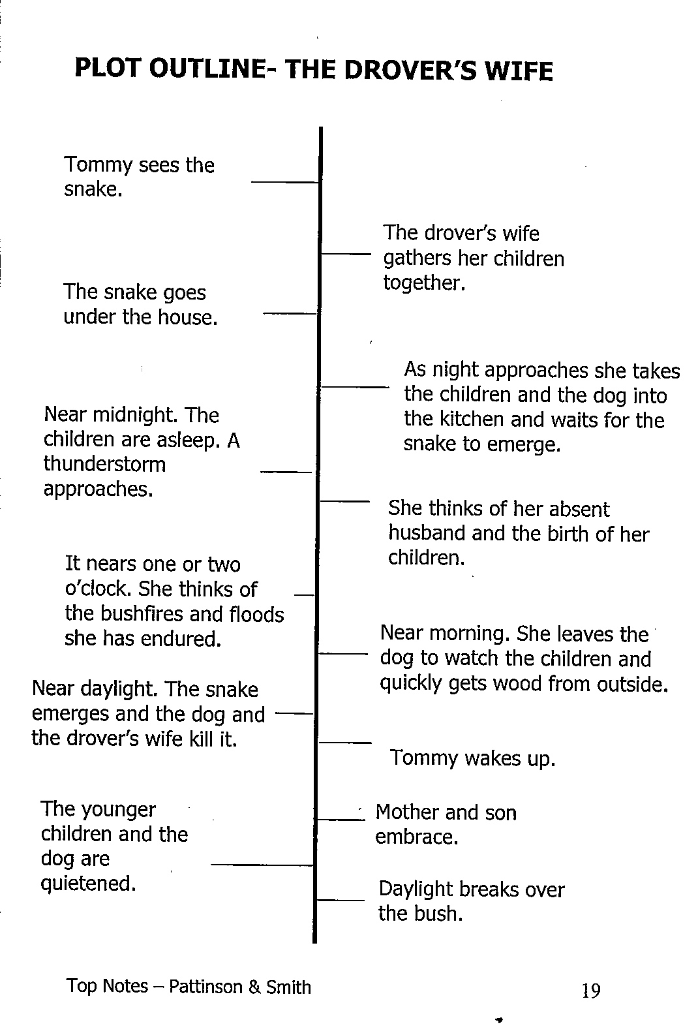
Henry Lawson wrote for The Bulletin, a popular Australian magazine which ran from 1880 to 2008. It began as a political and business journal, with some literary content.
In its early years, The Bulletin was known as the ‘bushman’s bible’ because of its nationalist, anti-imperialist, ‘radical’ political stance and racist views. In fact, the journal’s slogan was ‘Australia for the White Man’. This appealed to the male dominated frontier (rural) districts of late 19th Century Australia.

The Drover’s Wife was first published in The Bulletin on 23rd July 1892 and would have appealed to this audience given its depiction of the harsh reality of life in the bush and the portrayal of resilient women in light of the loneliness and dangers living in the outback entailed.

Glossary
The following words/phrases are listed in the order in which they appear in the story. As you read The Drover’s Wife highlight each of these words/phases and make a note of the meaning. WORD | DEFINITION
Shanty | A small, roughly built house, usually made of wood.
(Ex)squatter | A person who settles on land without right or title or payment of rent.
Gaunt | Extremely thin and bony; haggard.
Urchin | A mischievous boy; rascal.
Earthen (floor) | A floor made of dirt.
Blinded | An expletive of the time.
“skeezed” | Jacky means ‘squeezed’ by the other children in the bed.
Blanky | An expletive of the time.
Extricate | Free
Partition | An interior wall.
Remnant | Remaining quantity of sheep.
Provisions | Supplies of food and other necessities.
Fashion-plates | Illustrations showing the latest fashion in clothes.
Buggy | A light two-wheeled open carriage.
Gin | An abbreviation of ‘Aborigine’ – only used in reference to female Aborigines.
Bullock | A castrated bull.
Pleuro-pneumonia | An disease affecting the lungs of cattle.
Besieged | Surrounded
“in the horrors” | An informal expression for ‘delirium tremens’ – a withdrawal syndrome in people who have developed a dependence on alcohol, characterised by tremors, hallucinations and visible instability.
Sundowner | A homeless man who arrives at sunset so that he cannot be asked to do odd jobs in exchange for a place to stay.
Swagman | A vagrant (wanderer) who carries his personal belongings with him in a sack.
Prambulator | A pram.
Monotony | Wearisome uniformity or lack of variety.
“sense of the ridiculous” | The ability to find humour in the seemingly absurd.

The Drover’s Wife – Questions
- Consider the opening two paragraphs. How has Lawson enabled responders to visualise the isolated and infertile Australian landscape? In your answer, consider the effect of:
  - Visual imagery
  - Symbolism
  - Personification
- Lawson effectively conveys an image of the snake’s presence as threatening to the drover’s wife and her children. Analyse the language devices Lawson has used to achieve this image. In your answer, consider the effect of:
a) Dialogue (truncated sentences and exclamation)
b) Action verbs
c) Characterisation of Tommy
d) Characterisation of the drover’s wife
- What is the effect of calling the family dog “Alligator”? What distinctively visual image of the dog is conveyed to the responder?
- Explain the purpose of the temporal (time) shifts as a feature of the narrative structure. What is the impact of moving the story from sunset to sunrise?
- Lawson uses a series of flashbacks to develop the character of the drover’s wife. Identify these flashbacks in the story:
    - 1st flashback: Bushfire
    - 2nd flashback: Flood
    - 3rd flashback: Pleuro-pneumonia
    - 4th flashback: Mad bullock
Explain how Lawson has used each hardship to convey the distinctive characteristics of the drover’s wife.
- In what other ways does Lawson show that life in the bush is a day-to-day struggle?
- Identify TWO examples of humour. In what ways do these humorous incidents add to the distinctively visual image of life in the Australian bush?
- Read the story’s climatic scene – the ‘killing of the snake’. Analyse how Lawson has successfully enabled the responder to visualise this scene. In your answer, make reference to:
    - Variations in sentence length
    - Repetition
    - Onomatopoeia
    - Action verbs
    - Biblical allusion
- Why do you think Tommy declares at the end of the story that he: “won’t never go drovin’”? In what ways does his promise to his mother heighten the image of an abandoned wife and mother?
- Reflect on what is revealed about the drover throughout the story. How are we encouraged to view him?
- What are the distinct images that you see within the text?
- Write at least ONE concept statement which links to the text.
- Construct a body paragraph that addresses ONE concept statement written in question 12. Ensure you follow the TEEEL structure.

Distinct Images in ‘The Drover’s Wife’
Distinct Image | Techniques | Evidence- quotes | Effect
The Children
Climate/Climatic events
Dog
House
Landscape
Snake
Woman
The Drover

Concept Statements for ‘The Drover’s Wife’

- Authors construct images of femininity to confront audiences on lost hopes and lost dreams.
- The representations of the children reinforce the poverty and remoteness of the bush experience.
- The woman’s stoicism is a representation that has become synonymous with the country woman building expectations across generations of resourcefulness and resilience.
- The woman’s aggression is presented as instinct to highlight and infer her frustration and anger at the necessity of raising children alone in such isolation
- Historical images present the changing notions of an Australian image since the writing of this text.
- Woman in nineteenth century Australia were often regarded as delicate creature with small, two-dimensional roles within society.
- Authors confront their readers with the realities of the lives of the individuals and their need to change to survive.
- The use of distinctively visual language depicts to the audience the harsh realities of life in the bush and the constant threats to individuals.

Drover’s Wife: Sample Passage:
Question: “Henry Lawson uses Distinctively Visual images in ‘The Drover’s Wife’ to create a uniquely Australian story.”
The Drover’s Wife is a tale told in flashbacks and reflection capturing the hardships and struggles of an isolated bush-mother as a result of her choice to live in the Australian bush. In this tale Lawson develops through distinctively visual images a sense of the bush-woman and her surrounds which make the story uniquely Australian story.
The action and drama of ‘the drover’s wife’ is played out in a setting that is bleak and inhospitable in a way that only the Australian bush can be. When describing the bush setting Lawson emphasises a complete absence of physical features which creates an image of seclusion and abject isolation for the drover’s wife and her family. “Bush all around – bush with no horizon... No ranges in the distance…no undergrowth …nothing to relieve the eye …save a few she-oaks…above a narrow waterless creek.” By describing the setting as a place that lacks distinctive features Lawson creates a sense that the Australian bush is a location unlike any other and as such holds challenges and adversaries one would not find anywhere else. The distinctive image of the Australian bush setting opens the story as a uniquely Australian tale.
The values, beliefs and behaviours of characters in ‘The Drover’s Wife’ further characterise this story as uniquely Australian. The image of the drover’s wife springing actively onto the scene at the first sign of trouble portrays her as a complex and contradictory figure that could only be Australian….
Through these various language and stylistic techniques Lawson creates distinctively visual images that tell a story that is uniquely Australia.

In this story, we accompany the narrator on their train journey from Bathurst to Bourke. The narrator relays to us a picture of the landscape “all along the New South Wales western line” and the typical types of people encountered along the way. In many ways it is a ‘nightmare’ trip, with the narrator encountering a number of people with ‘odd’ behaviour.
In this respect, Lawson is capitalising on the notion that people love to share and compare ‘horror’ trips and derive enjoyment from humorously discussing the people they saw and the strange behaviours or incidents they observed.
Purpose
In a Dry Season is representative of Lawson’s typical ‘sketch’ style, rather than being a ‘sketch-story’. The sketch shows us how the reality of the bush impacts upon and is reflected in those who live there. Thus, the purpose of this sketch is to “draw” a picture of the bush landscape in the heat of summer and compose portraits of the Australian people that can be found there.
Audience
First published in the in The Bulletin on 5th November 1892, the story is based on Lawson’s own experience of travelling to Bourke in September 1892.
A sketch such as In a Dry Season enabled Lawson to present the ‘country’ to the ‘city’. In an effort to maintain realism and avoid presenting the bush as a ‘rural paradise’, Lawson relies on a number of stereotypes in this sketch. As a result, his characters are painted broadly, enabling the sketch to convey a visually compelling picture of society in the bush.
The Bush Undertaker – Analysis of the Distinctly Visual
Henry Lawson uses many language devices to show that prolonged isolated living in the tough and unrelenting Australian bush has an indelible effect on its occupants, often warping them and making them “weird” or “eccentric”
Complete the following activities to analyse how Lawson creates these images of the harsh environment, dangerous wildlife and isolation.
Harsh environment
- In the opening paragraph Lawson creates an image of the harsh Australian environment. Identify 4 different adjectives used to describe the environment that start with a plosive “b” sound and explain how these words portray the environment.
- The corpse represents the inherent danger posed by the dangerous environment. Write a line from the text that describes this grotesque image and explain one language technique used to help the reader visualise this disturbing scene.
Dangerous wildlife (Goannas)
- Throughout the story, Lawson makes reference to the growing threat of the Goannas. Look at the following sentences and explain how Lawson hints at their menace through describing distinctly visual .
- “great greasy black goanna clambered up a sapling from under his feet and looked fightable.
- “saw another goanna gliding off sideways, with its long snaky neck turned towards him.”
- ”there was a great black goanna in violent convulsions on the ground.”
- “wretch has a-follered me 'ome, an' has been a-havin' its Christmas dinner off of Brummy, an' a-hauntin' o' me into the bargain, the jumpt-up tinker!"
Isolation (Loss of language skills)
- Lawson purposely uses Australian Use of Australian colloquialism to represent the nationality of the Bush Undertaker. Find 3 examples of Australian colloquialisms and explain what they mean

- All of the Bush Undertaker’s Dialogue is written phonetically, with incorrect grammar, syntax and an informal register.

- Read the following piece of dialogue and rewrite it in modern english
"I tole yer so, Brummy," he said impressively, addressing the corpse. "I allers told yer as how it 'ud be--an' here y'are, you thundering jumpt-up cuss-o'-God fool. Yer cud earn more'n any man in the colony, but yer'd lush it all away. I allers sed as how it 'ud end, an' now yer kin see fur y'self.
- Why does he speak in this manner? What does it suggest about the impact of isolation on the Bush Undertaker?
- How does this auditory imagery affect the reader?

Isolation (The Undertaker’s humorous but odd activities)
The actions of the Bush Undertaker seem odd to the audience as they occur well outside the social norms and etiquette of established civilisation. These events are depicted in a humorous way to amuse the audience and highlight the effect bush living has on its occupants.
- “Dinner proceeded very quietly, except when the carver paused to ask the dog how some tasty morsel went with him, and Five Bob's tail declared that it went very well indeed” How does Lawson use language here to make the image of man and dog having a formal dinner humorous? (Make reference to this line and the line that follows directly after it)

- For amusement, the undertaker decides to dig up some Aboriginal remains and analyse them. By calling the character “The Bush Undertaker,” Lawson is already drawing attention to his macabre hobby and pokes fun at his attempts at scientific experimentation. Write the line that depicts this activity and explain how Lawson’s use of formal language and scientific jargon makes the image comical.

- When the Bush Undertaker returns to his home with Brummy’s corpse, he treats it as if it’s still alive, which suggests his isolation and need for company. He is “used to the weird and dismal, as one living alone in the bush must necessarily be.”

- Identify a line from the text that personifies the corpse and explain how this affects the reader’s visualisation of the corpse.
- This grotesque image is lightened by the Bush Undertaker’s threatening dialogue with the vacant corpse. Read the following except and identify 2 different language devices Lawson has used to depict this odd image explain how they produce humour.
"Now, look a-here, Brummy," said he, shaking his finger severely at the delinquent, "I don't want to pick a row with yer; I'd do as much for yer an' more than any other man, an' well yer knows it; but if yer starts playin' any of yer jumpt-up pranktical jokes on me, and a-scarin' of me after a-humpin' of yer 'ome, by the 'oly frost I'll kick yer to jim-rags, so I will."
Isolation (Forgetting of societal norms)
- Complete the following cloze passage
After saving Brummy from the hungry _________________, the Bush Undertaker decides to conduct a ______________ for his friend. However he has difficulty remembering the _____________ and only has his shepherding tools to carry it out. This leads to a comical and blundering ceremony which demonstrates how isolated from _______________ society he has become. “He carried it to the grave and dropped it into one corner like a______________. He arranged the bark so as to cover the____________, and, by means of a piece of_________________ , lowered the body to a horizontal position. Then he threw in an armful of________________ , and then, very reluctantly, took the shovel and dropped in a few shovelfuls of earth” The ______________“like a post” both makes reference to his ______________ fencing sheep, but also the ______________manner in which he buries the body. When attempting the funeral rites, he “said with a _________________that greatly disturbed Five Bob: "Hashes ter hashes, dus ter dus, Brummy--an'--an' in hopes of a great an' gerlorious_________________!" His _____________________of the important religious words reiterate how ____________ such ceremonies are from his day to day life, but also ______________that the rituals of urban civilisation are unnecessary in the harsh Australian_____________. The image of this bush funeral helps the reader visualize how ___________ old traditions are in this environment
solemnity | out of place | funeral | experience | rassaraction | Goannas
outback | mispronunciation | clumsy | face | clothes-line | distant
highlights | gum-leaves | post | ritual | traditional | simile

Survival
- Lawson ends his story with the image of the Bush Undertaker after the funeral,
“He sat down on a log near by, rested his elbows on his knees and passed his hand wearily over his forehead--but only as one who was tired and felt the heat; and presently he rose, took up the tools, and walked back to the hut. And the sun sank again on the grand Australian bush--the nurse and tutor of eccentric minds, the home of the weird”
Why do you think he ends on this image? (Hint – what does it suggest about the Bush Undertaker’s lifestyle)
- The final line of the story resonates with the theme of the text itself; “the sun sank again on the grand Australian bush--the nurse and tutor of eccentric minds, the home of the weird.” Explain in your own words how the Bush Undertaker’s isolation and exposure to the landscape has affected him, making reference to the events of this story.
The Bush Undertaker – Sample Extended Response
Henry Lawson’s short story “The Bush Undertaker” creates distinctive images which depict how prolonged isolated living in the tough and unrelenting Australian bush has an indelible effect on its occupants, often warping them and making them “weird” or “eccentric.” Lawson introduces the reader to the harsh Australian environment by using alliterative words with negative connotations such as “broiling”, “barren” and “bare, brown ridges” to describe the protagonist’s home. The plosive “b” sound of these words creates a harsh and confronting tone, already suggesting that living in this environment is a battle. This ongoing danger is reiterated when the Bush Undertaker discovers Brummy’s corpse. Lawson purposely creates a grotesque image by describing its desperate and disturbing appearance in detail “shrivelled eyes seemed to peer up at him from under the blackened wrists.” He adds sound to the image in “the flesh sounded like leather.” This simile links the disturbing image to an everyday sound which highlights the harsh reality of what happens if you don’t learn to adapt to the Australian environment.
The protagonist of this text has been clearly affected by living in isolation. He is no longer able to communicate clearly and exhibits eccentric behaviours. Lawson ironically refers to the bushman as a “soliloquizer,” then writes his dialogue phonetically which draws attention to his poor pronunciation, grammar and syntax, “I aller’s told yer as how it ‘us be … you thundering jumpt-up cuss-o’-God fool.” This contrast creates humour for the reader, but also demonstrates that his isolation has had a negative effect on his communication skills. Further, the reader is alienated from the character as the dialogue is initially difficult to read, however the auditory image it creates allows the reader to accurately hear him speaking. His eccentric behaviours and hobbies are depicted humorously through contrast. Lawson uses formal language and scientific jargon when describing the bushman’s examination of the bones, “speculating as to whether they had belonged to black or white, male or female. Failing, however, to arrive at any satisfactory conclusion, he dusted them with great care, put them in the bag” The protagonist is clearly not a scientist and the careful action he is taking is different to his casual attitude toward his actual occupation, shepherding. This image would appear humorous as his attempts to be scientific are ridiculous in his situation. This incongruity between image and description draws attention to the odd way the bushman amuses himself. A formal dinner with a dog, playing coroner with Aboriginal remains, conversing with a corpse and conducting a funeral are all odd leisure activities, but in this desolate environment are necessary to keep the bushman sane.
Lawson ends the story by portraying the bushman after the funeral. His gestures “he rested his elbows on his knees and passed his hand wearily over his forehead--but only as one who was tired and felt the heat” suggest that he is upset by the loss of his friend and is taking a minute to mourn. However the hyphens show that he is in fact only hot and tired and must return to work, as he must to ensure physical and mental survival. The final personified line “the sun sank again on the grand Australian bush--the nurse and tutor of eccentric minds, the home of the weird” reiterates the effect living in the isolating and dangerous Australian environment has had on the main character, making the Bush Undertaker “weird and eccentric”

Distinct Images in ‘The Bush Undertaker’
Distinct Image | Techniques | Evidence- quotes | Effect
Bush Landscape
Dog
Brummy
Goannas
The old man

Concept Statements for ‘The Bush Undertaker’

- Lawson’s literal imagery is embedded with colonial notions of individualism.
- The literal imagery of the landscape is an anthropomorphic representation of the protagonist‟s social angst.
- The imagery, distinctive in both the literal and philosophical sense, represents the arrogance of white men believing they could dominate the landscape.
- Images of the dog reflect the intuitive notion of the bush as a place of fear and misrepresentation.
- Lawson’s text reflects how images of bush stoicism as reduced to madness as a consequence of the isolating imperatives of creating a national white history.
- Ironic representations of burial rites and ritual present opportunity to explore how the images presented here are a reflection of the time in which the text was produced.

Constructing a body paragraph

- What are the distinct images that you see within the text?
- Write at least ONE concept statement which links to the text.
- Construct a body paragraph that addresses ONE concept statement written in question 2. Ensure you follow the TEEEL structure.
- T- Topic Sentence
- E- Explain/Expand
- E- Examples and technique/s
- E-Evaluate
- L- Link

Prescribed Text # 3- ‘In a Dry Season’- Short Story

Analysis
In a Dry Season – Section 1
Draw a wire fence and a few ragged gums, and add some scattered sheep running away from the train. Then you’ll have the bush all along the New South Wales western line from Bathurst on.
The railway towns consist of a public house and a general store, with a square tank and a school-house on piles in the nearer distance. The tank stands at the end of the school and is not many times smaller than the building itself. It is safe to call the pub "The Railway Hotel," and the store "The Railway Stores," with an "s." A couple of patient, ungroomed hacks are probably standing outside the pub, while their masters are inside having a drink--several drinks. Also it's safe to draw a sundowner sitting listlessly on a bench on the veranda, reading “the Bulletin”. The Railway Stores seem to exist only in the shadow of the pub, and it is impossible to conceive either as being independent of the other. There is sometimes a small, oblong weather-board building--unpainted, and generally leaning in one of the eight possible directions, and perhaps with a twist in another--which, from its half-obliterated sign, seems to have started as a rival to the Railway Stores; but the shutters are up and the place empty.
The only town I saw that differed much from the above consisted of a box-bark humpy with a clay chimney, and a woman standing at the door throwing out the wash-up water.
By way of variety, the artist might make a water-colour sketch of a fettler's tent on the line, with a billy hanging over the fire in front, and three fettlers standing round filling their pipes.
From the extract above, find examples of each of the following techniques:
1. Negative adjectives: few, ragged and scattered suggests empty expanse of landscape, and that it is unchanging
2. High modality words and hyperboles: suggesting little variation in landscape
3 Australian Colloquialisms: Depict an image of men working on the railway using Australian colloquialism
4. Imperative voice: gives command to audience to sketch the repetitive images he is seeing from his train window. Invites reader to participate in the story and witness the journey at close hand.
5. Stereotypical Descriptions: Lawson suggests the stereotypical inhabitants of outback bush towns are also to be found everywhere. Shows effect living in these monotonous towns has had on inhabitants “ungroomed” “listless” and most likely drunk.

In a Dry Season – Section 2
Slop sac suits, red faces, and old-fashioned, flat-brimmed hats, with wire round the brims, begin to drop into the train on the other side of Bathurst; and here and there a hat with three inches of crape round the crown, which perhaps signifies death in the family at some remote date, and perhaps doesn't. Sometimes, I believe, it only means grease under the band. I notice that when a bushman puts crape round his hat he generally leaves it there till the hat wears out, or another friend dies. In the latter case, he buys a new piece of crape. This outward sign of bereavement usually has a jolly red face beneath it. Death is about the only cheerful thing in the bush.
We crossed the Macquarie--a narrow, muddy gutter with a dog swimming across, and three goats interested.
A little farther on we saw the first sundowner. He carried a Royal Alfred, and had a billy in one hand and a stick in the other. He was dressed in a tail-coat turned yellow, a print shirt, and a pair of moleskin trousers, with big square calico patches on the knees; and his old straw hat was covered with calico. Suddenly he slipped his swag, dropped his billy, and ran forward, boldly flourishing the stick. I thought that he was mad, and was about to attack the train, but he wasn't; he was only killing a snake. I didn't have time to see whether he cooked the snake or not--perhaps he only thought of Adam.
Somebody told me that the country was very dry on the other side of Nevertire. It is. I wouldn't like to sit down on it any where. The least horrible spot in the bush, in a dry season, is where the bush isn't--where it has been cleared away and a green crop is trying to grow. They talk of settling people on the land! Better settle in it. I'd rather settle on the water; at least, until some gigantic system of irrigation is perfected in the West.
From the extract above, find examples of each of the following techniques:
- Stereotypical Descriptions: Detailed description of a stereotypical swagman, again his clothes symbolize his struggle, old damaged, falling apart material.
- Symbolism: Clothes symbolize low income and struggle, also suggests that people are only differentiated by their clothes. They are not characterized, and are left anonymous.
- Third person: suggesting “government,” demonstrates Lawson believes social injustice is evident here.
- First person narration: directly showing Lawson’s opinion.

In a Dry Season – Section 3
Along about Byrock we saw the first shearers. They dress like the unemployed, but differ from that body in their looks of independence. They sat on trucks and wool-bales and the fence, watching the train, and hailed Bill, and Jim, and Tom, and asked how those individuals were getting on.
Here we came across soft felt hats with straps round the crowns, and full-bearded faces under them. Also a splendid-looking black tracker in a masher uniform and a pair of Wellington boots.
One or two square-cuts and stand-up collars struggle dismally through to the bitter end. Often a member of the unemployed starts cheerfully out, with a letter from the Government Labour Bureau in his pocket, and nothing else. He has an idea that the station where he has the job will be within easy walking distance of Bourke. Perhaps he thinks there'll be a cart or a buggy waiting for him. He travels for a night and day without a bite to eat, and, on arrival, he finds that the station is eighty or a hundred miles away. Then he has to explain matters to a publican and a coach-driver. God bless the publican and the coach-driver! God forgive our social system!
Native industry was represented at one place along the line by three tiles, a chimney-pot, and a length of piping on a slab.
Somebody said to me, "Yer wanter go out back, young man, if yer wanter see the country. Yer wanter get away from the line." I don't wanter; I've been there.
You could go to the brink of eternity so far as Australia is concerned and yet meet an animated mummy of a swagman who will talk of going "out back." Out upon the out-back fiend!
From the extract above, find examples of each of the following techniques:
1: Simile: suggests despite having money, they still dress scruffily and blend in with the vagrants and drunks.
2. Hyperbole: About the wide expanse of environment. Negative image of “mummy” swagman suggests the impact of the dry climate
3. Exclamation and insults: Lawson’s anger at romanticised idea of the cruel “outback”
____
In a Dry Season – Season 4
About Byrock we met the bush liar in all his glory. He was dressed like--like a bush larrikin. His name was Jim. He had been to a ball where some blank had "touched" his blanky overcoat. The overcoat had a cheque for ten "quid" in the pocket. He didn't seem to feel the loss much. "Wot's ten quid?" He'd been everywhere, including the Gulf country. He still had three or four sheds to go to. He had telegrams in his pocket from half a dozen squatters and supers offering him pens on any terms. He didn't give a blank whether he took them or no. He thought at first he had the telegrams on him but found that he had left them in the pocket of the overcoat aforesaid. He had learned butchering in a day. He was a bit of a scrapper himself and talked a lot about the ring. At the last station where he shore he gave the super the father of a hiding. The super was a big chap, about six-foot-three, and had knocked out Paddy Somebody in one round. He worked with a man who shore four hundred sheep in nine hours.
Here a quiet-looking bushman in a corner of the carriage grew restless, and presently he opened his mouth and took the liar down in about three minutes.
At 5.30 we saw a long line of camels moving out across the sunset. There's something snaky about camels. They remind me of turtles and goannas.
Somebody said, "Here's Bourke."
From the extract above, find examples of each of the following techniques:
1. Imagery: of sameness and Lawson’s general dislike for Australian animals as being “snakey” suggests they are deceitful or untrustworthy
2. Short and simple sentences: cumulate to represent the liar’s extensive deception. This helps the reader imagine being present.
3. Short direct dialogue: showing they have reached their destination that lacks any description shows Lawson’s disinterest in the outback and suggests it is no different to the rest of the inhospitable environment he has described throughout the story.
Concept Statements for ‘In A Dry Season’

- The artistic representation is a deliberate construct that evokes a reaction to the distinctive lack of a single Australian persona.
- The Australian outback was romanticised and once believed to be an exciting place of adventure and opportunity.
- Author’s represent the monotony and sameness of outback Australian towns.
- Lawson suggests that individuals living in outback towns have similar experiences and struggles.

Constructing a body paragraph

- What are the distinct images that you see within the text?
- Write at least ONE concept statement which links to the text.
- Construct a body paragraph that addresses ONE concept statement written in question 2. Ensure you follow the TEEEL structure.

Distinct Images in ‘In A Dry Season’
Distinct Image | Techniques | Evidence- quotes | Effect
Landscape
Personalities
Buildings
Clothing

In a Dry Season – Sample Extended Response
Lawson’s “In a Dry Season” depicts the harsh reality of living in the inhospitable Australian Outback and the affect it has on its occupants through the homodiegetic narration of Lawson’s real life journey to Bourke from Sydney in 1982. He begins the sketch using imperative voice to direct the reader to “Draw a wire fence and a few ragged gums, and add some scattered sheep running away from the train. Then you'll have the bush all along the New South Wales western line from Bathurst on.” The responder is invited to visualize the uniform desolation of the landscape through negative adjectives. Lawson’s description remain economical and refers to the features of most country towns in general plural terms using indefinite articles, reiterating the monotony Lawson and the reader is experiencing.
Lawson instead focuses on the individuals who struggle with adversity in this environment by using their clothing to symbolise their stereotypical characters. “Slop sac suits, red faces, and old-fashioned, flat-brimmed hats, with wire round the brims, begin to drop into the train on the other side of Bathurst” These Australian hats signify that their wearers are poor and uncomfortable and also allude to their position in society. Lawson’s description of another stereotype “the bush liar – like a larrikin” and his use of the bush vernacular spelt phonetically, “wots ten quid” and censored cuss words “blanky” allow the reader to access this auditory imagery and visualize his eccentric behaviour.
Throughout the text, Lawson’s dry and cynical attitude is salient. He recognises the struggle experienced by those living in the outback and attempts to subvert romantic imagery of the outback, made popular by his contemporaries. This is shown through his authorial comments such as “Death is about the only cheerful thing in the bush” which is a sarcastic paradox that alludes to the danger posed in the bush, but also the complete boredom experienced within it. Lawson uses a vivid image of “an animated mummy of a swagman who will talk of going "out back." And then responds “Out upon the out-back fiend!” which depicts the physical affect the hot and dry climate have upon the human body. The swagman’s love for the “outback” is countered by Lawson’s insult and exclamation, which reiterates his need to portray the Australian outback realistically. Thus, through the use of realistic and harsh imagery, Lawson shows that The harsh conditions of the Australian outback has a negative impact on its occupants
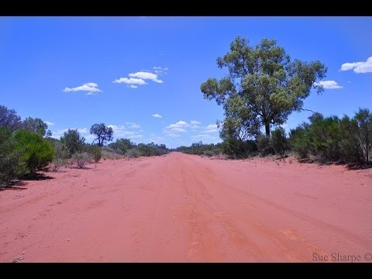

Prescribed Text #4- ‘The Loaded Dog’- Short Story
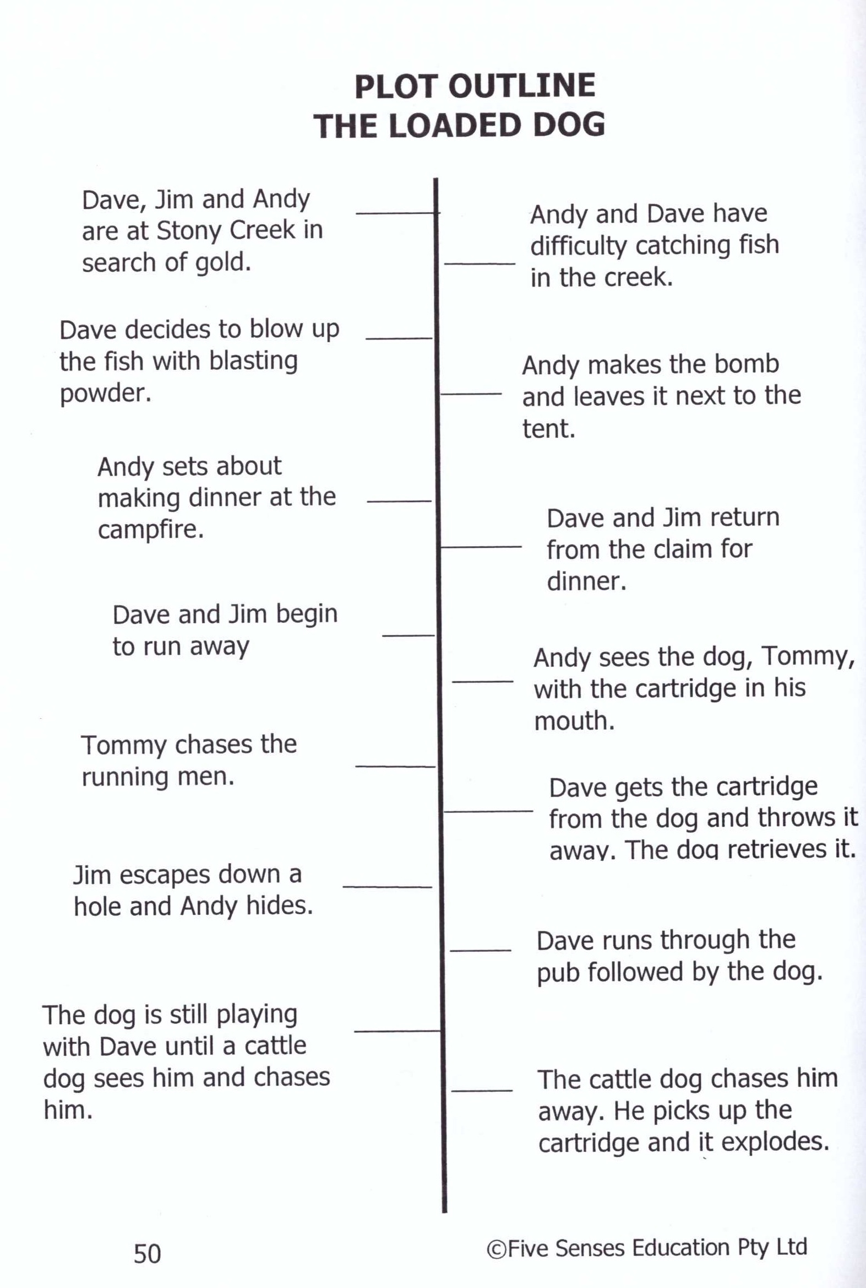
This story is one of Lawson’s most popular stories and if often found in anthologies (a collection of short stories), including those designed for children. What makes it so effective is the humorous way in which Lawson treats a potentially dangerous situation. Readers laugh at the many close calls that are described but there is a sense of black humour about how fraught with danger everyday life could be. The story is sometimes described as a “grim rural comedy”.
Purpose:
Entertains with the dog chasing the men and blowing up the other dog and it informs with the idea of the importance of mateship in the bush.
Plot:
A group of men (Dave, Jim and Andy) are camping and use cartridges to blow up ground searching for gold. They get sick of fishing the normal way, so they decide to blow up the fish in the waterhole. When the cartridge is built, the dog steals it and accidentally lights it. Tommy (the dog) chases the men with it, and in the end blows up this other yellow dog that nobody likes.
Themes:
- Human interaction with the environment and associated consequences of manipulating it.
- Human and dog relationship, importance of mateship in the bush. No discrimination amongst characters; dog is an important friend

Narrative Structure:
Orientation: The three men are camping on a riverbank searching for gold. They invent a way of using blasting powder to catch fish since the conventional way is ineffective.
Complication: Tommy lights the fuse in the fire and chases the men.
Middle: The tale is crafted to describe the humorous details of Tommy chasing the men who desperately try to avoid him. Tommy eventually has a whole town running from him, while he is enjoying all the excitement and attention.
Climax: Tommy is confronted by a vicious yellow mongrel cattle-dog who chases Tommy and steals the cartridge from him.
Resolution: The yellow dog is blown up and other pack dogs suffer burns. The Bushmen laugh in hysterics. Dave apologizes but it is remembered for years afterward.
Language Techniques to consider:
- Use of humour throughout. The descriptions are embellished to excite the audience.
- Detailed descriptions of how the cartridge is made, where the dog chases them, their reactions and the consequences all appeal strongly to the audience. The story is comical and hilarious since we emotionally connect to the group.
- Limited presence of an authorial voice makes a more unified tone and is told by an observer who exaggerates comic detail.
- Strong tension crisis and dramatic imagery dog grinned, legs started before his brain.
- Action words eg swooped, bound round (assonance), spluttering, dive, flung, burst, jolt, wedged, etc
- Short paragraphs build tension
- Descriptive language
- Humorous tone
- Sardonic humour, bitterly mocking, cynical, negative look at the world.

The Loaded Dog Questions

- Consider the characters in the story:
- Dave Regan
- Andy Page
- Jim Bently
Explain, with detailed reference to language forms and features, how Lawson has successfully established each as a distinctive character in the story.
- Lawson describes the construction of the explosive in great detail. What language devices has he used to enable responders to clearly visualise the cartridge itself and the danger it poses?
- As responders, we are positioned to accept Tommy as a loveable “overgrown pup”. How does Lawson successfully persuade us to view Tommy as a harmless, fun-loving companion to Dave, Andy and Jim? In your answer, make specific reference to the following:
- Diction used to describe Tommy
- Anthropomorphism
- Contrast with the “vicious yellow mongrel cattle-dog”

- Once the chase scene begins, the story increases in pace. How has Lawson achieved this increase in pace? What is the effect?
- Lawson uses unfinished or ‘hanging’ sentences as a way of heightening suspense. Find TWO examples of ‘hanging sentences’ in The Loaded Dog and quote them below, explaining how the use of this type of sentence encourages the responder to infer/visualise what has happened.
- Read the ending of the story. Find examples of TWO different types of humour that Lawson has used to convey the death of the yellow dog as humorous occurrence.
- Reflect on the characterisation of the yellow dog. Why do we feel that he is deserving of his death?
- What are the distinct images that you see within the text?
- Write at least ONE concept statement which links to the text.
- Construct a body paragraph that addresses ONE concept statement written in question 9. Ensure you follow the TEEEL structure.

Distinct Images in ‘The Loaded Dog’
Distinct Image | Techniques | Evidence- quotes | Effect
Landscape
Tommy- dog
Other dogs
Dave Regan
Jim Bentley
Andy

Concept Statements for ‘The Loaded Dog’

- The Loaded Dog‟ constructs visuals that are both humourous and satirical in an attempt to paint a picture of the range of archetypal Australian bush identities.
- Pace and tension are used as literary devices in ‘The Loaded Dog’ to engage readers in the chaos of the usual image of isolation and boredom of the Australian bush.
- Insight into mateship is a focus of ‘The Loaded Dog’ reinforcing Lawson’s expressions of the idealistic Australian identity.
- The dogs are representations of society and its inhabitants. Lawson is highlighting the loss of integrity and the disparate nature of intent and motive in the Australian bush.

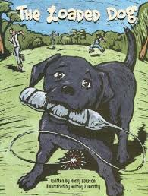

Past HSC Questions
2016:
Analyse how experiences and attitudes are conveyed by the use of distinctive images in the texts you have studied. In your response, make detailed reference to your prescribed text, including the extract provided below, and ONE other related text.

‘The railway town consists of a public house and a general store, with a square tank and a schoolhouse on piles in the nearer distance. The tank stands at the end of the school and is not many times smaller than the building itself. It is safe to call the pub ‘The Railway Hotel’, and the store ‘The Railway Stores’, with an ‘s’. A couple of patient, ungroomed hacks are probably standing outside the pub, while their masters are inside having a drink – several drinks. Also it’s safe to draw a sundowner sitting listlessly on a bench on the verandah, reading The Bulletin.’ (from In a Dry Season)
2015:
Distinctive images offer a variety of perspectives on the world. Compare how this is achieved in your prescribed text and ONE other related text of your own choosing.
2014:
How do the qualities of distinctive images create interest and draw us into the experiences of others? In your response, refer to your prescribed text and ONE other related text of your own choosing.
2013:
How does the use of the distinctively visual emphasise the ways that individuals resond to significant aspects of life? In your response, make detailed reference to your prescribed text and ONE other related text of your own choosing.
2012:
Interesting views on society are conveyed by the distinctively visual. Explore how this is achieved in your prescribed text and ONE other related text of your own choosing.
2011:
In what ways are people and their experiences brought to life through the distinctively visual? In your response, make detailed reference to your prescribed text and at least ONE other related text of your own choosing.
2010:
Compare the ways the distinctively visual is created in your prescribed text and ONE other related text of your own choosing.
2009:
Discuss how the distinctively visual conveys distinctive experiences in your related text and ONE other related text of your own choosing.
Other:
Distinctive images are created for different purposes. How is this shown in your prescribed text and at least ONE other text of your own choosing? (2010 CSSA Trial)

Practice Essay Question
In what ways are people and their experiences brought to life through the distinctively visual? In your response, make detailed reference to your prescribed text and at least ONE other related text of your own choosing.
Essay Planning Scaffold
Introduction
Re-worded question: ____________________________________________________________________________________________________________________________________________________________________________________________________________________________________________________________________________________
Thesis statement: ____________________________________________________________________________________________________________________________________________________________________________________________________________________________________________________________________________________
Text names/author/form/year:
____________________________________________________________________________________________________________________________________________________________________________________________________________________________________________________________________________________
Distinctly visual definition: ______________________________________________________________________________________________________________________________________________________________________________________________________________________________________________________________________________________________________________________________________________________________________________________________________________________________
Chosen texts and techniques: _______________________________________________________________________________________________________________________________________________________________________________________________________________________________________________________________________________________________________________________________________________________________________________________________________________________________________________________________________________________________________________________________________________________________________
Sample Introduction:
Distinctively visual images within texts bring people and their experiences to life. This is evident in Henry Lawson’s 1892 short stories ‘The Drover’s Wife’ and ‘In A Dry Season.’ Lawson effectively utilises language techniques such as symbolism, exclamation marks and onomatopoeia to depict the survival of characters within a harsh and threatening environment. He also makes use of plurals and stereotypical characters within ‘In A Dry Season’ to suggest that individuals living in outback towns have similar experiences and struggles. Nick Ut’s 1972 photograph ‘Terror of War’ effectively projects the individual’s pain into the world through the deliberate use of a powerful salient image, as well as contrasting images in the foreground and background.

Paragraph 1 – Henry Lawson_________________________________________(Title of text) First Short Story
Topic Sentence
Expand/Explain
Examples/techniques

Evaluate

Link back to question and topic sentence

Paragraph 2 – Henry Lawson_________________________________________(Title of text) First Short Story
Topic Sentence
Expand/Explain
Examples/techniques

Evaluate

Link back to question and topic sentence

Paragraph 3 – Henry Lawson_________________________________________(Title of text) Second Short Story
Topic Sentence
Expand/Explain
Examples/techniques

Evaluate

Link back to question and topic sentence

Paragraph 4 – Henry Lawson_________________________________________(Title of text) Second Short Story
Topic Sentence
Expand/Explain
Examples/techniques

Evaluate

Link back to question and topic sentence

Paragraph 5 – Related Text_________________________________________(Title of text) _________________________________ (Composer and year)
Topic Sentence
Expand/Explain
Examples/techniques

Evaluate

Link back to question and topic sentence

Paragraph 6 – Related Text_________________________________________(Title of text) _________________________________ (Composer and year)
Topic Sentence
Expand/Explain
Examples/techniques

Evaluate

Link back to question and topic sentence

Conclusion
Reiteration of Thesis statement/point of view: ________________________________________________________________________________________________________________________________________________________________________________________________________________________________________________________________________________________________________________________________________________________________________________________________
Restate title/composer of the texts discussed:
________________________________________________________________________________________________________________________________________________________________________________________________________________________________________________________________________________________________________________________________________________________________________________________________
Restate the techniques discussed: ________________________________________________________________________________________________________________________________________________________________________________________________________________________________________________________________________________________________________________________________________________________________________________________________
Final statement:
________________________________________________________________________________________________________________________________________________________________________________________________________________________________________________________________________________________________________________________________________________________________________________________________
Things to remember
1.Write in 3rd person unless asked specifically for YOUR opinion
2.Use formal language
3.Don’t use contractions
4.Write numbers using words (two, not 2)
5.Underline the texts’ titles
6.Refer to the author by surname
7.Use speech marks for all quotes
8.Don’t retell the story

Sample A-Range Response
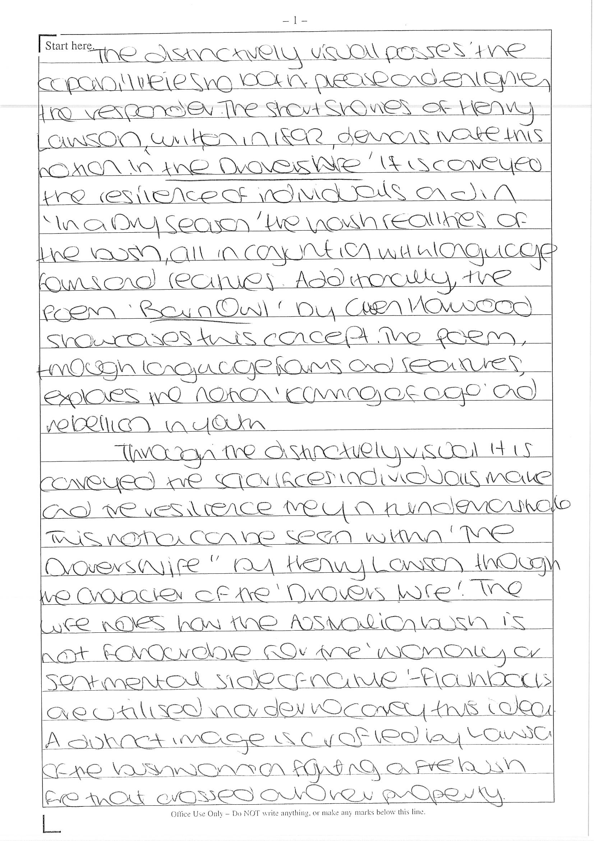

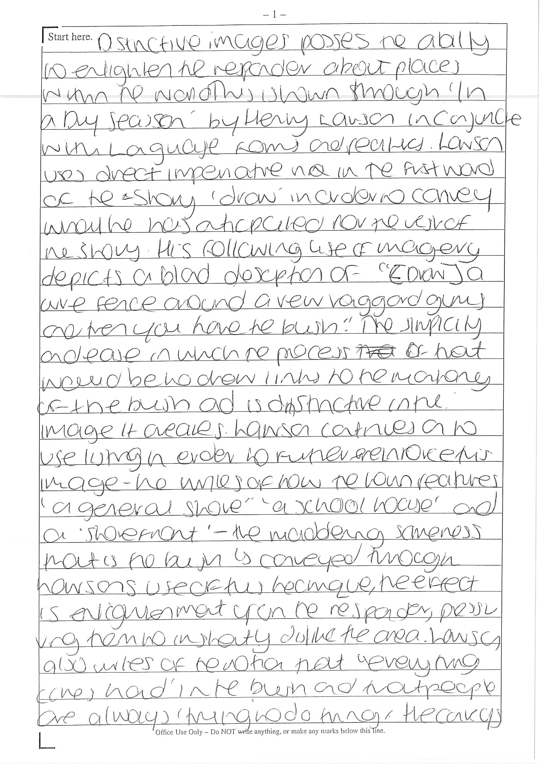
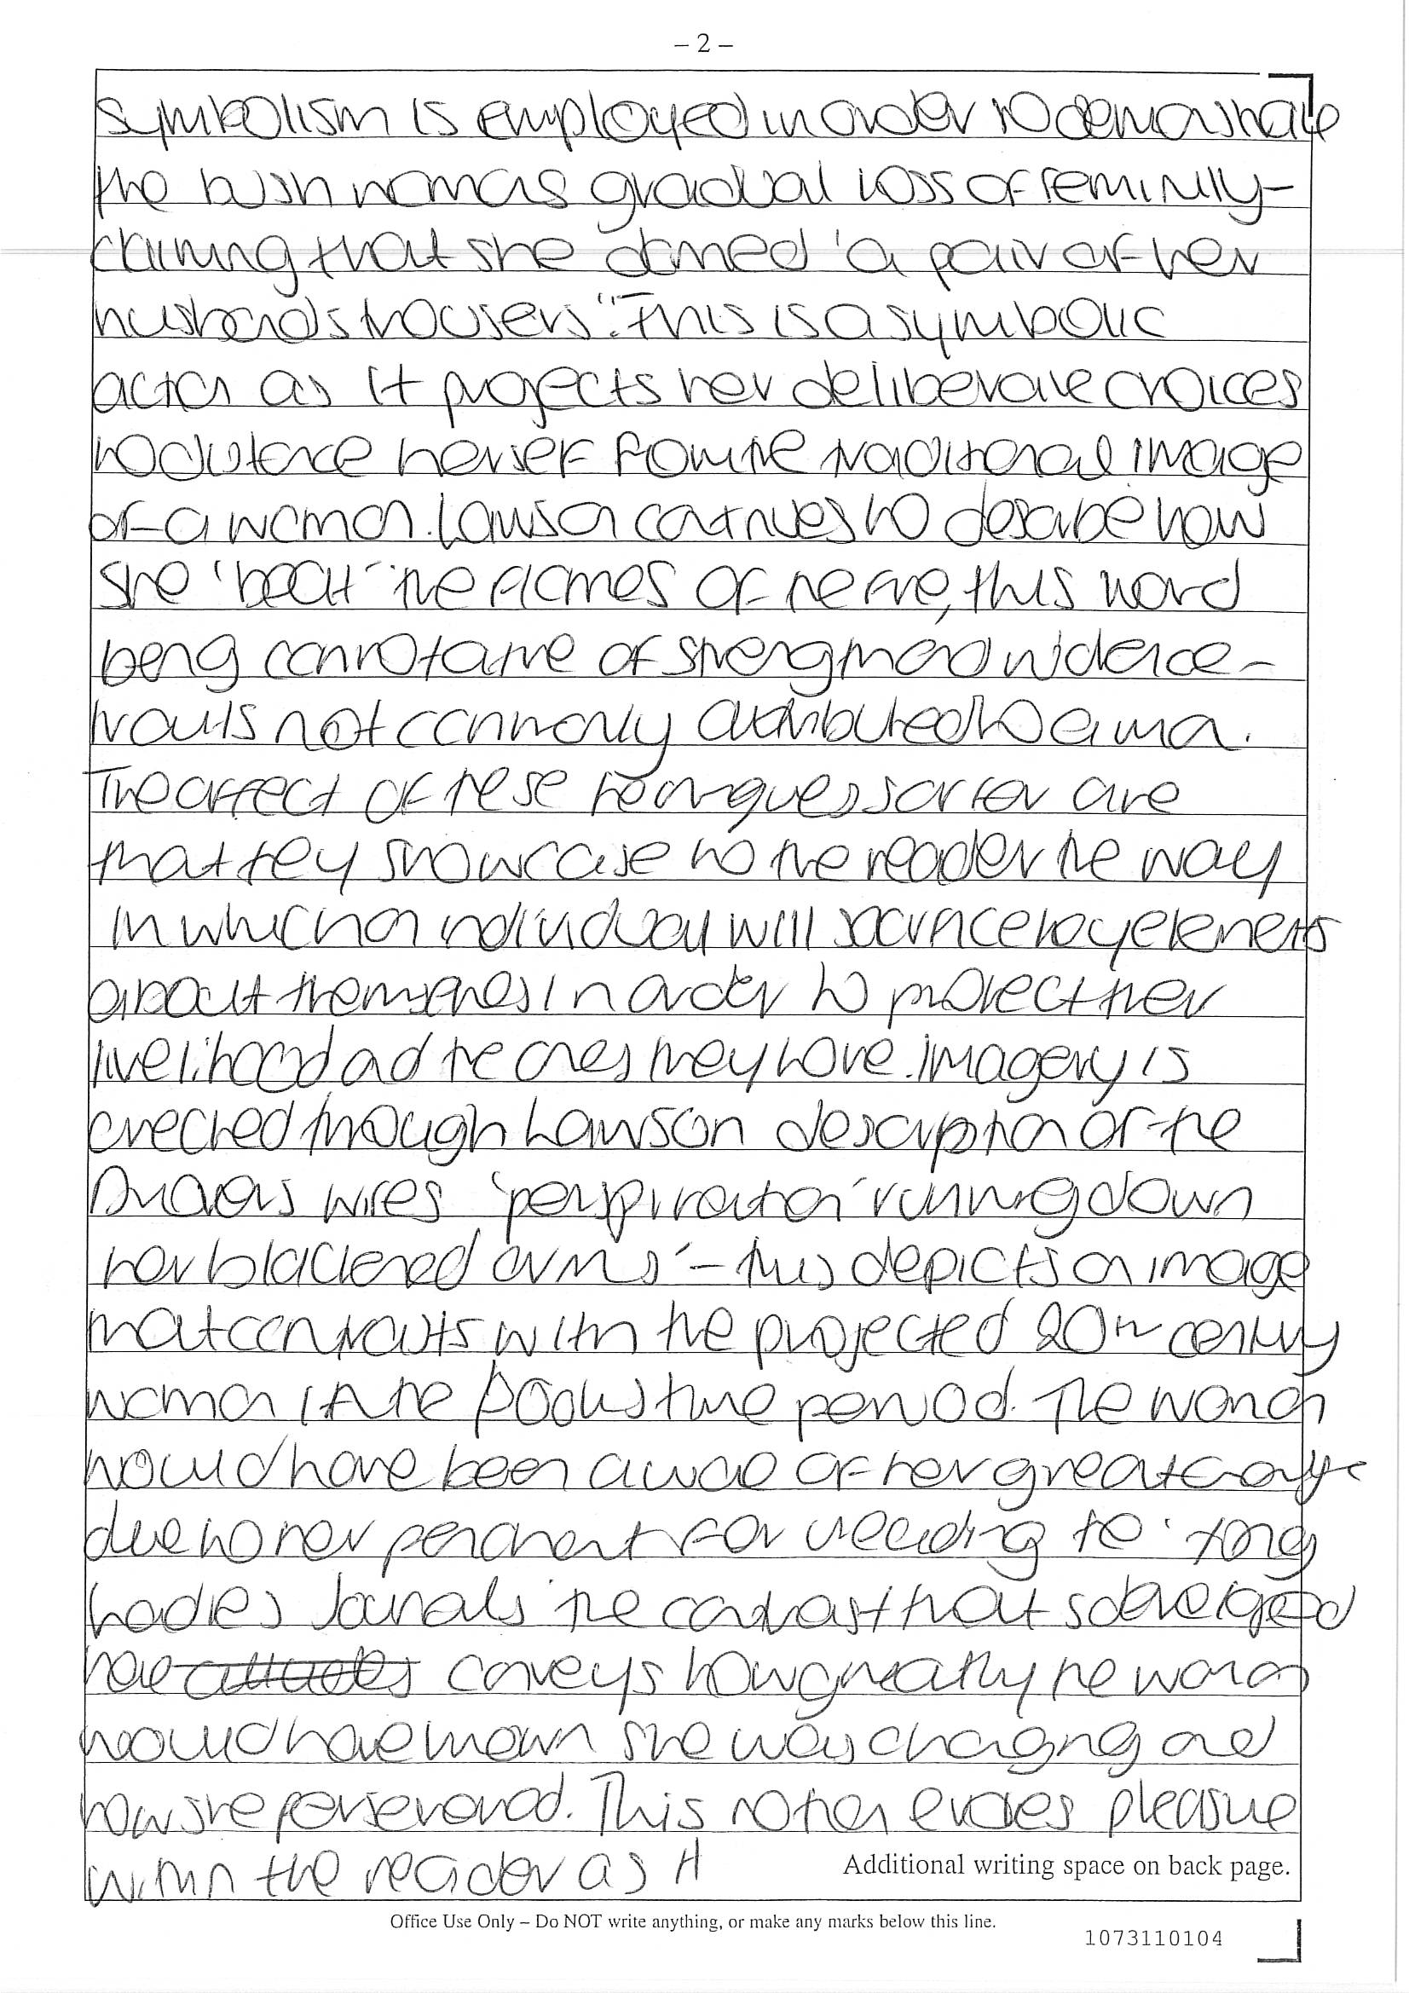

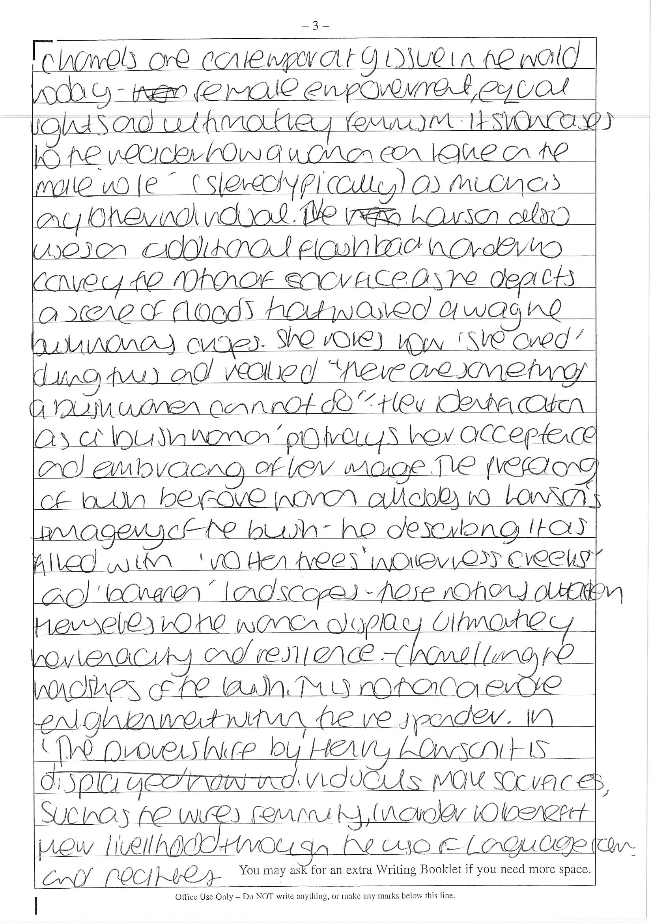
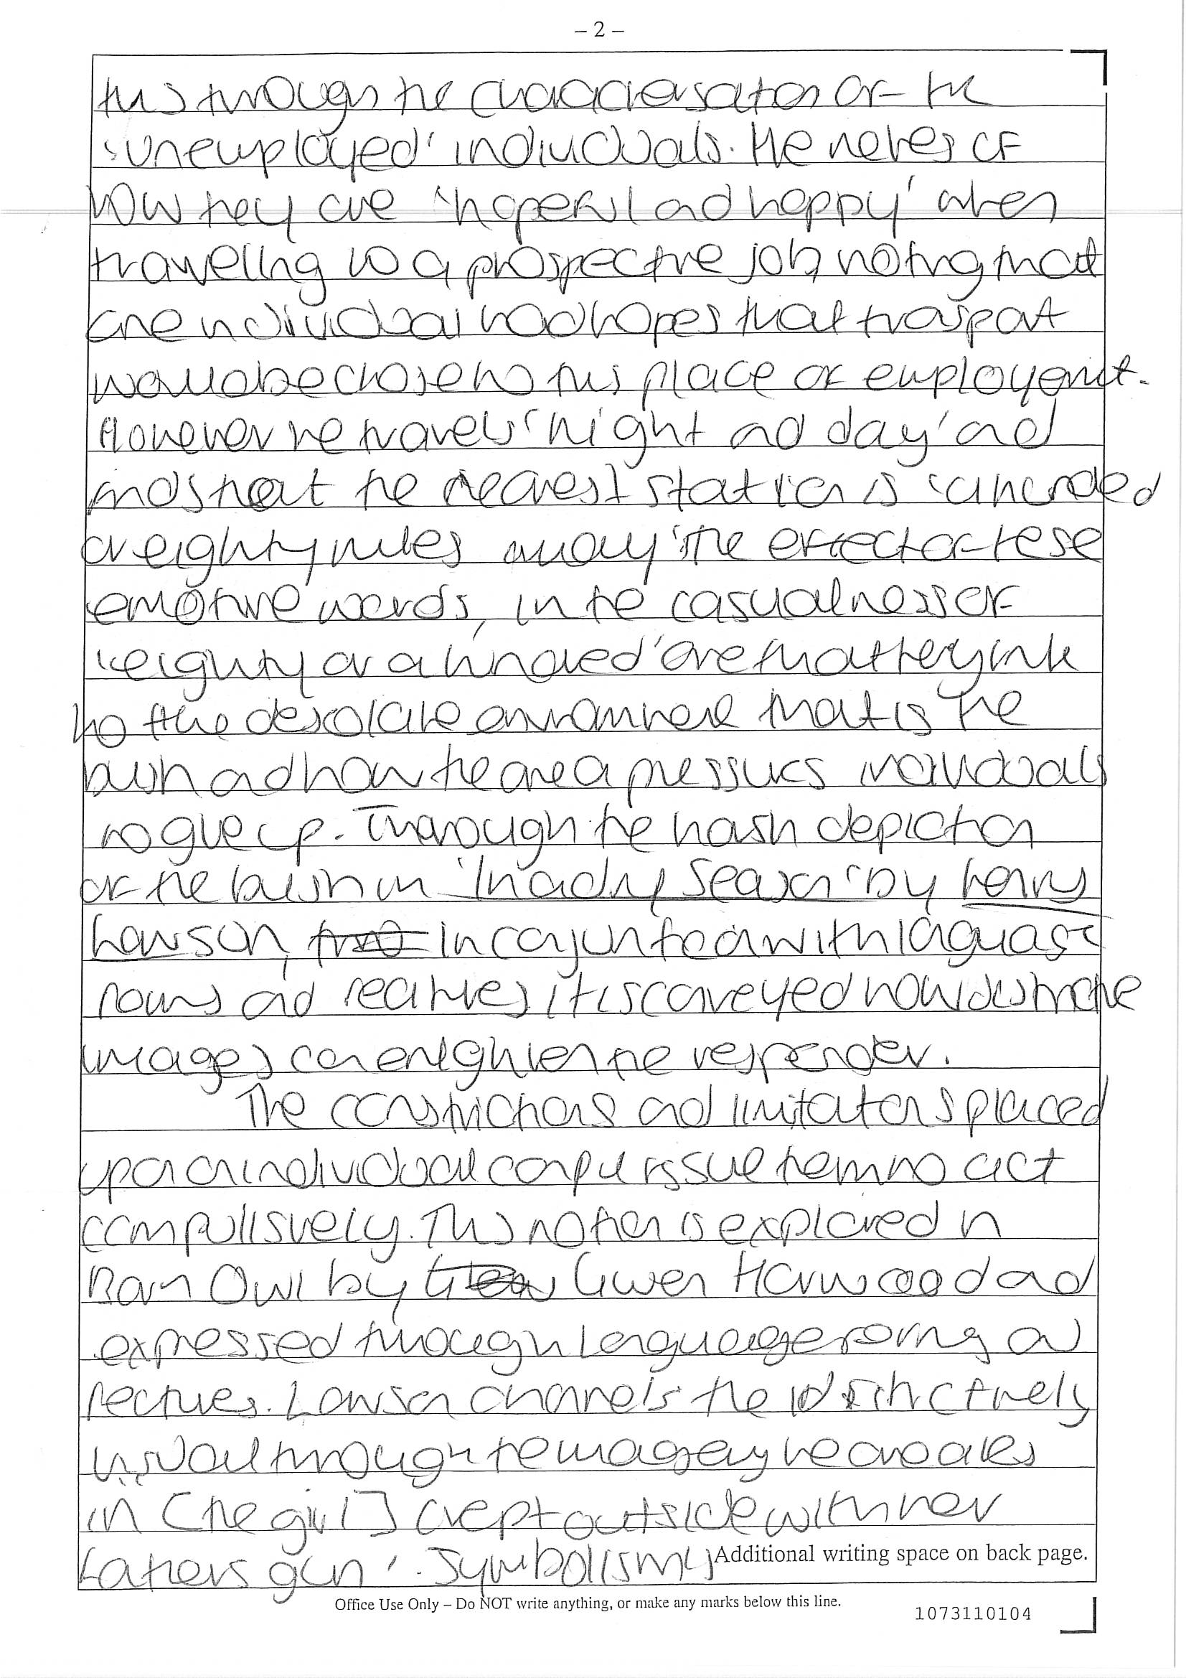
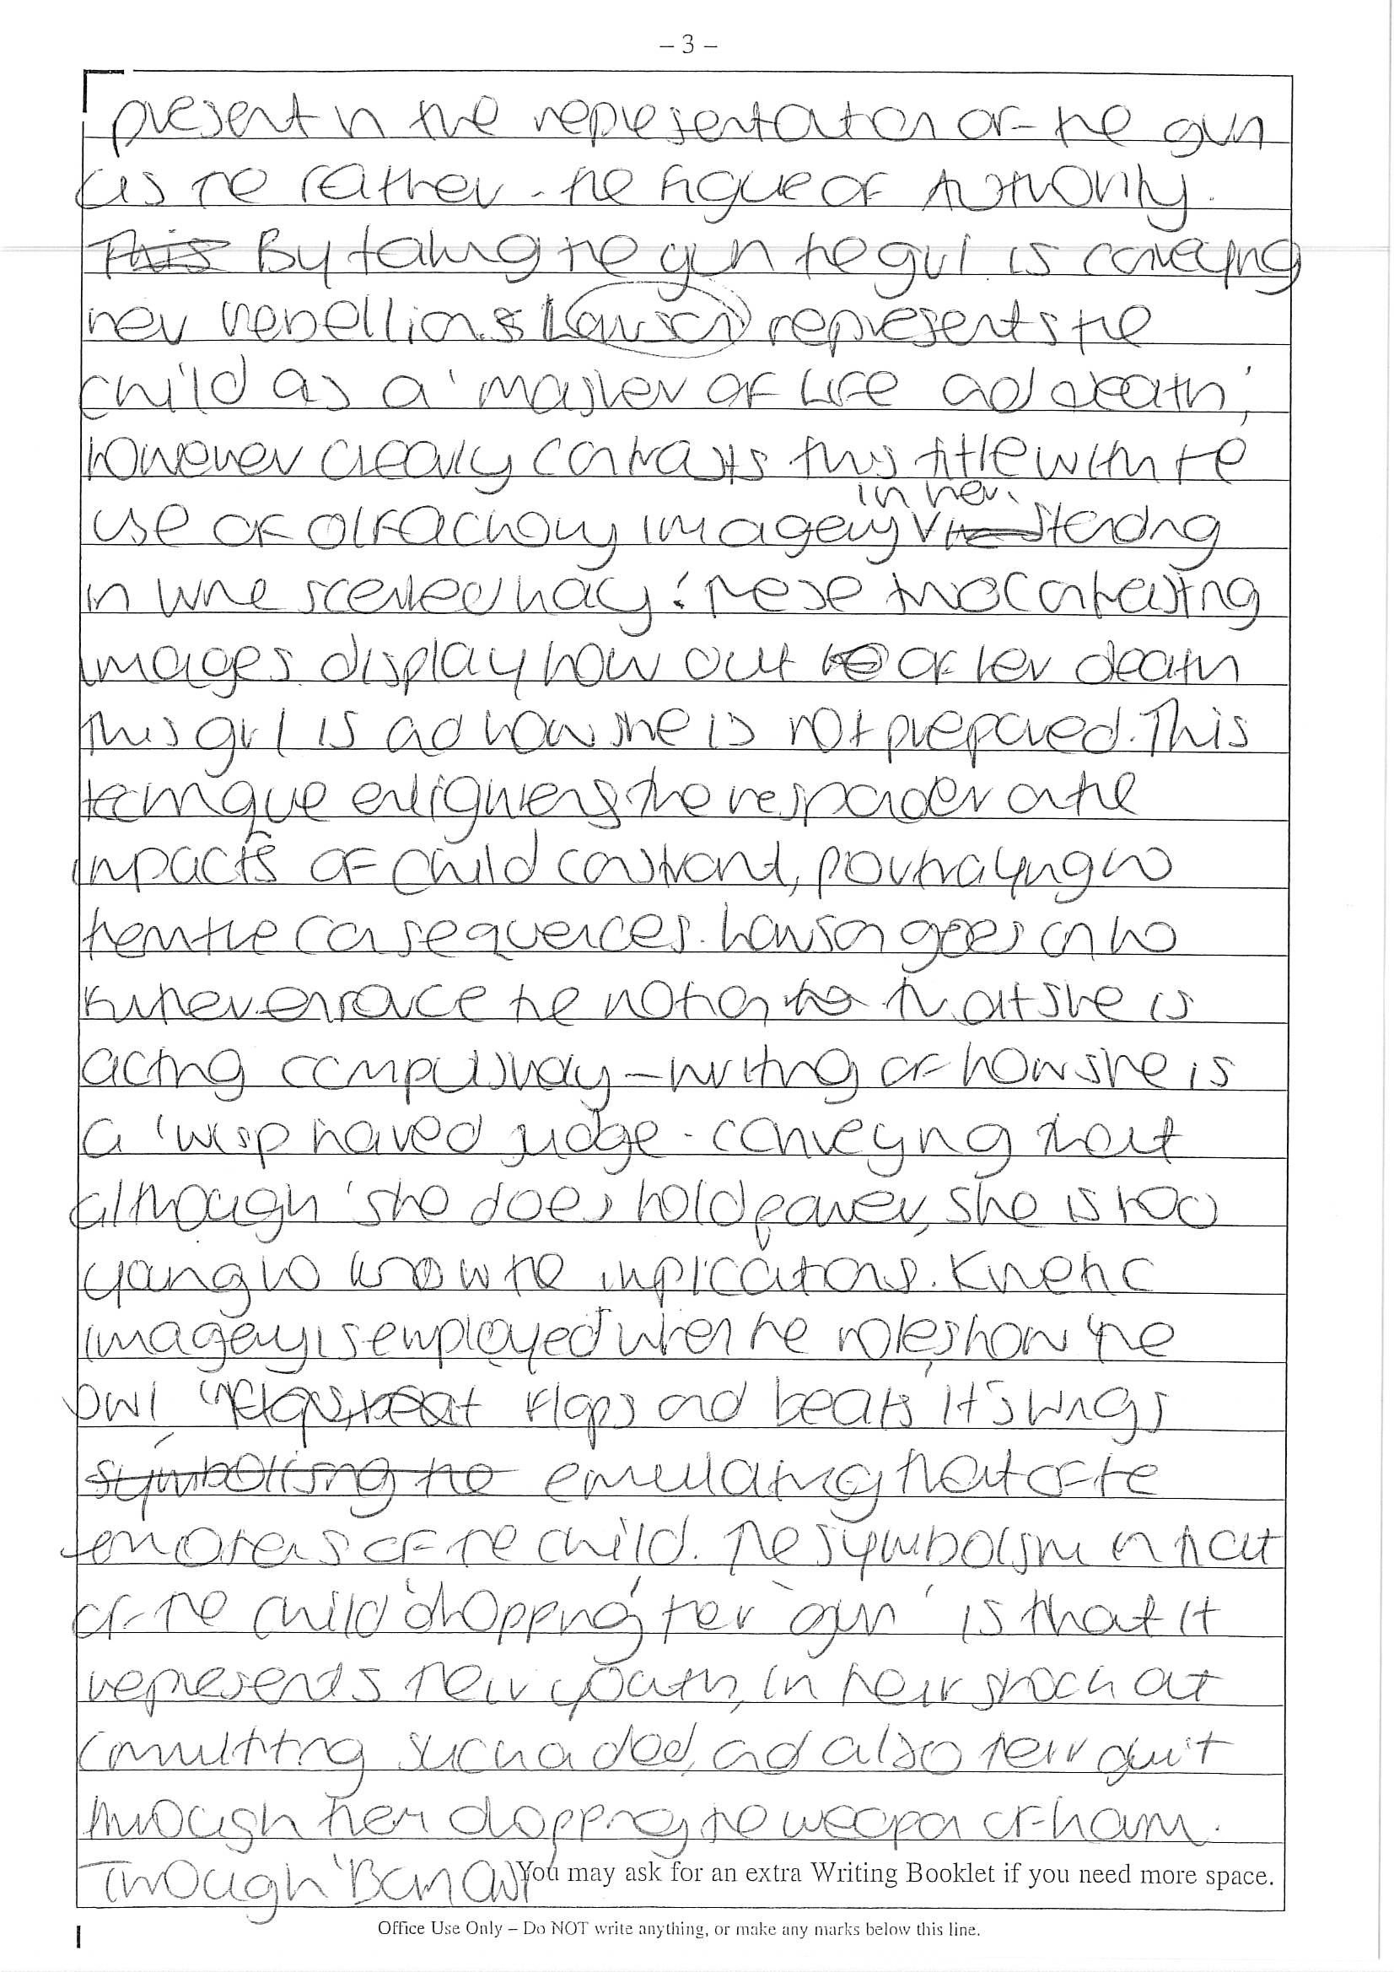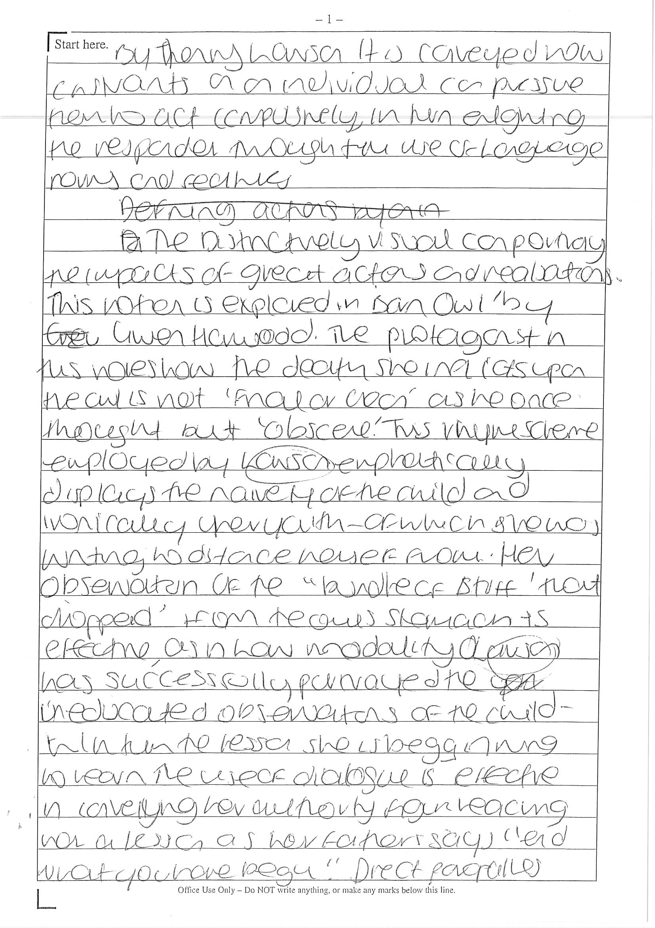

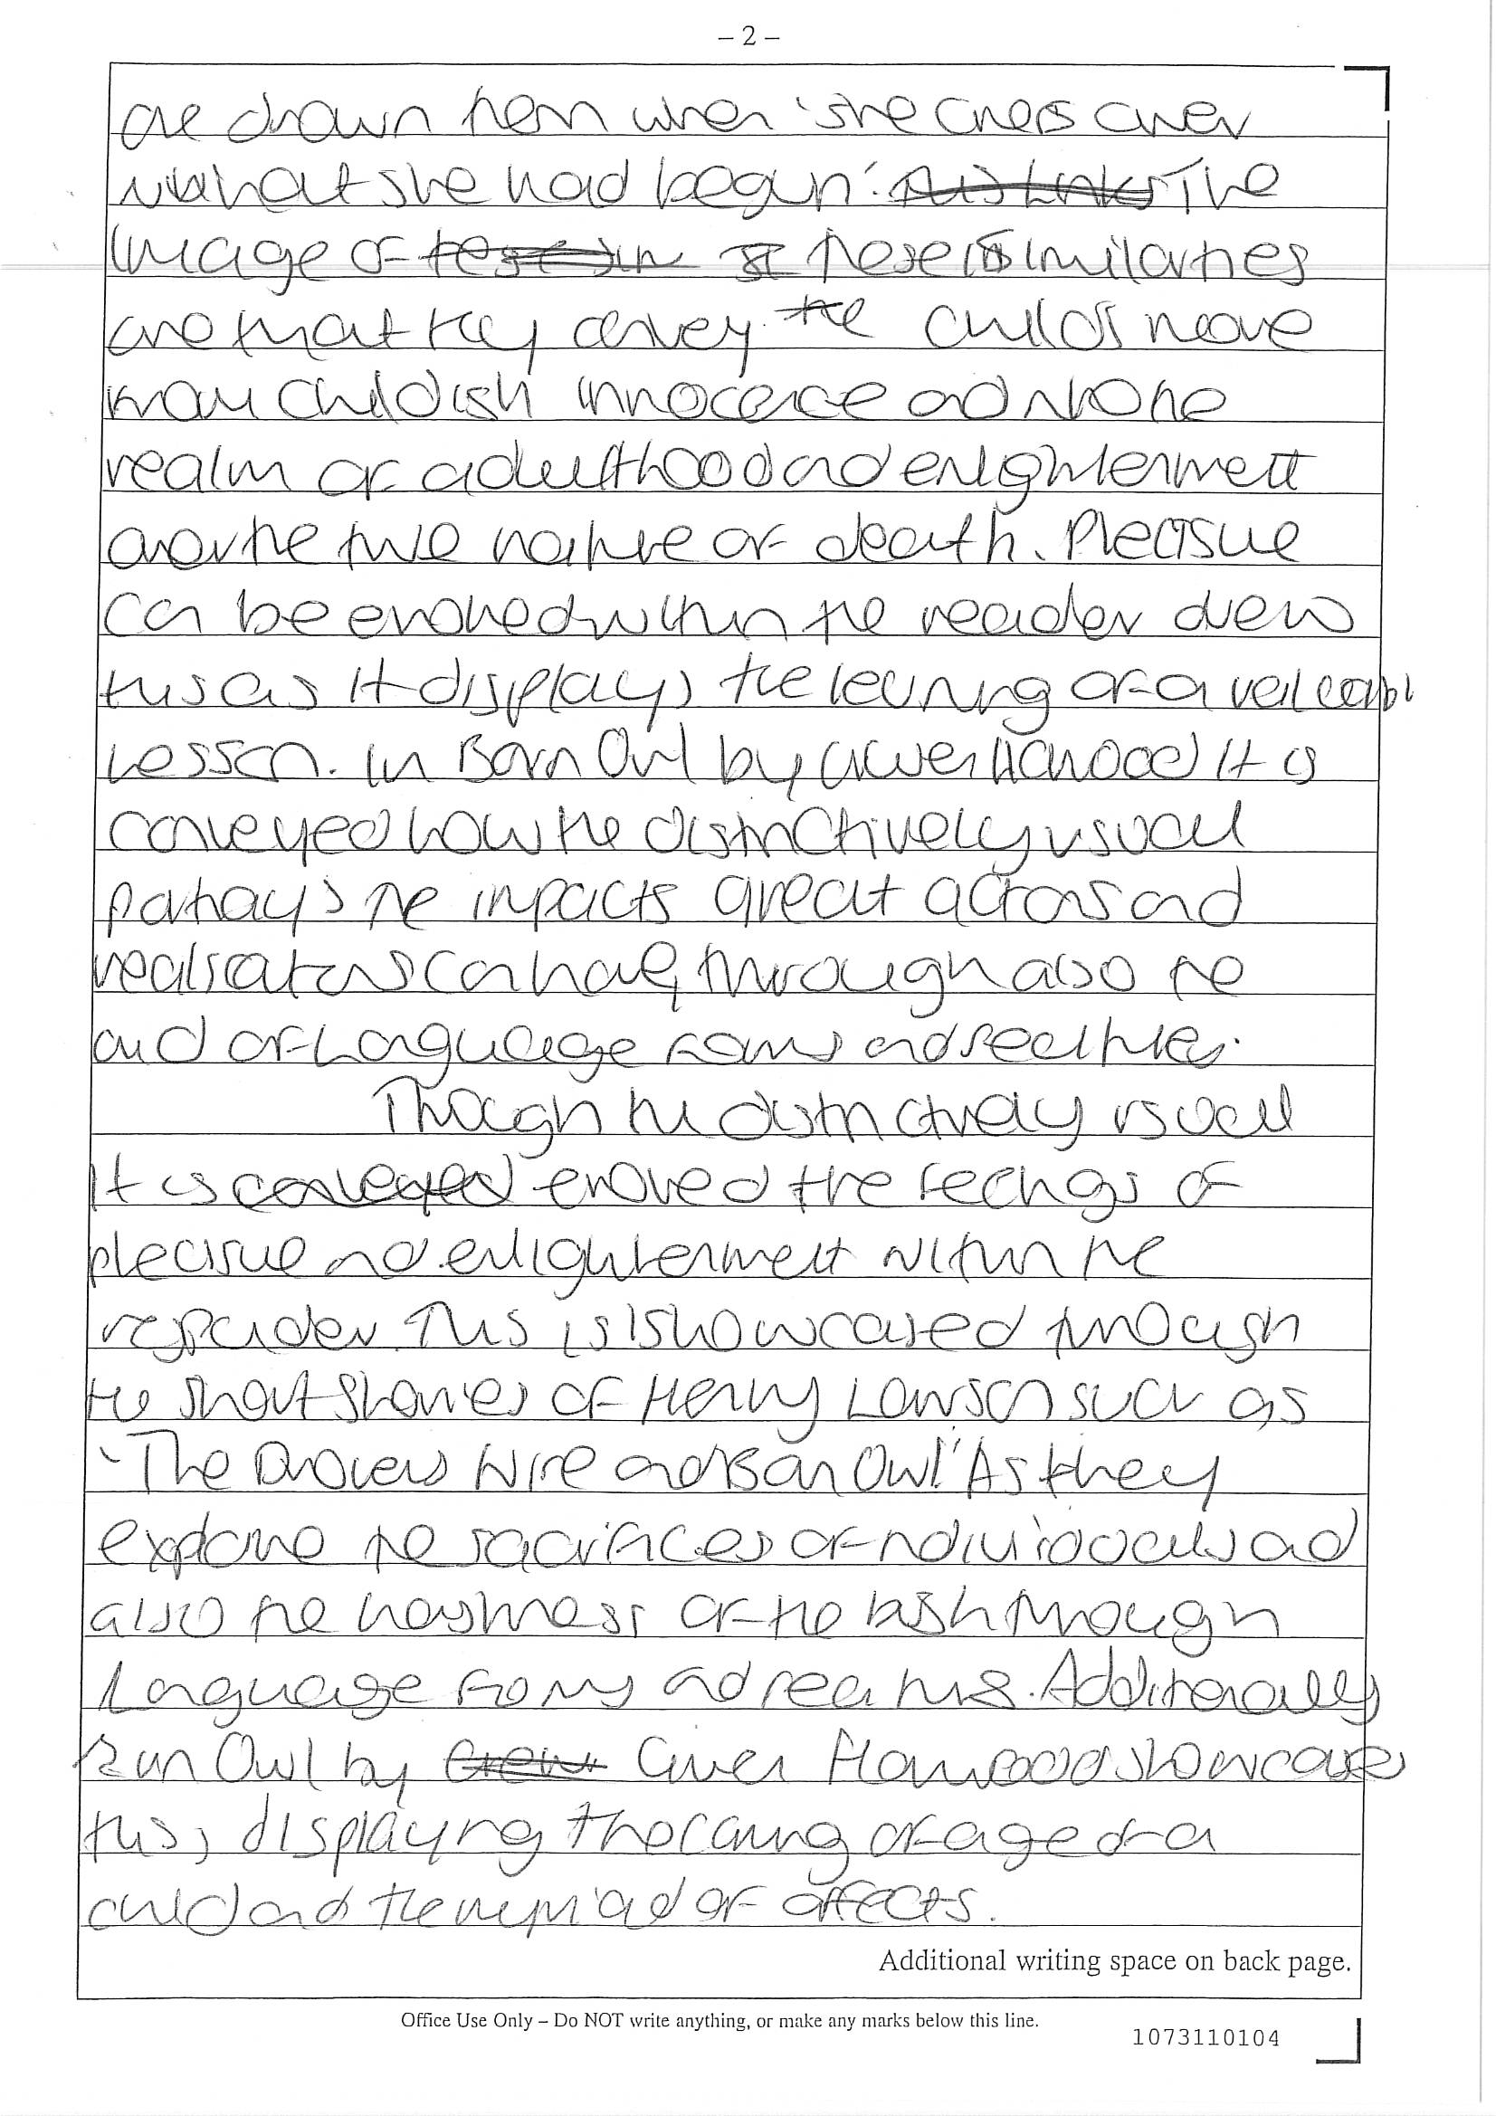

Sample A-Range Response
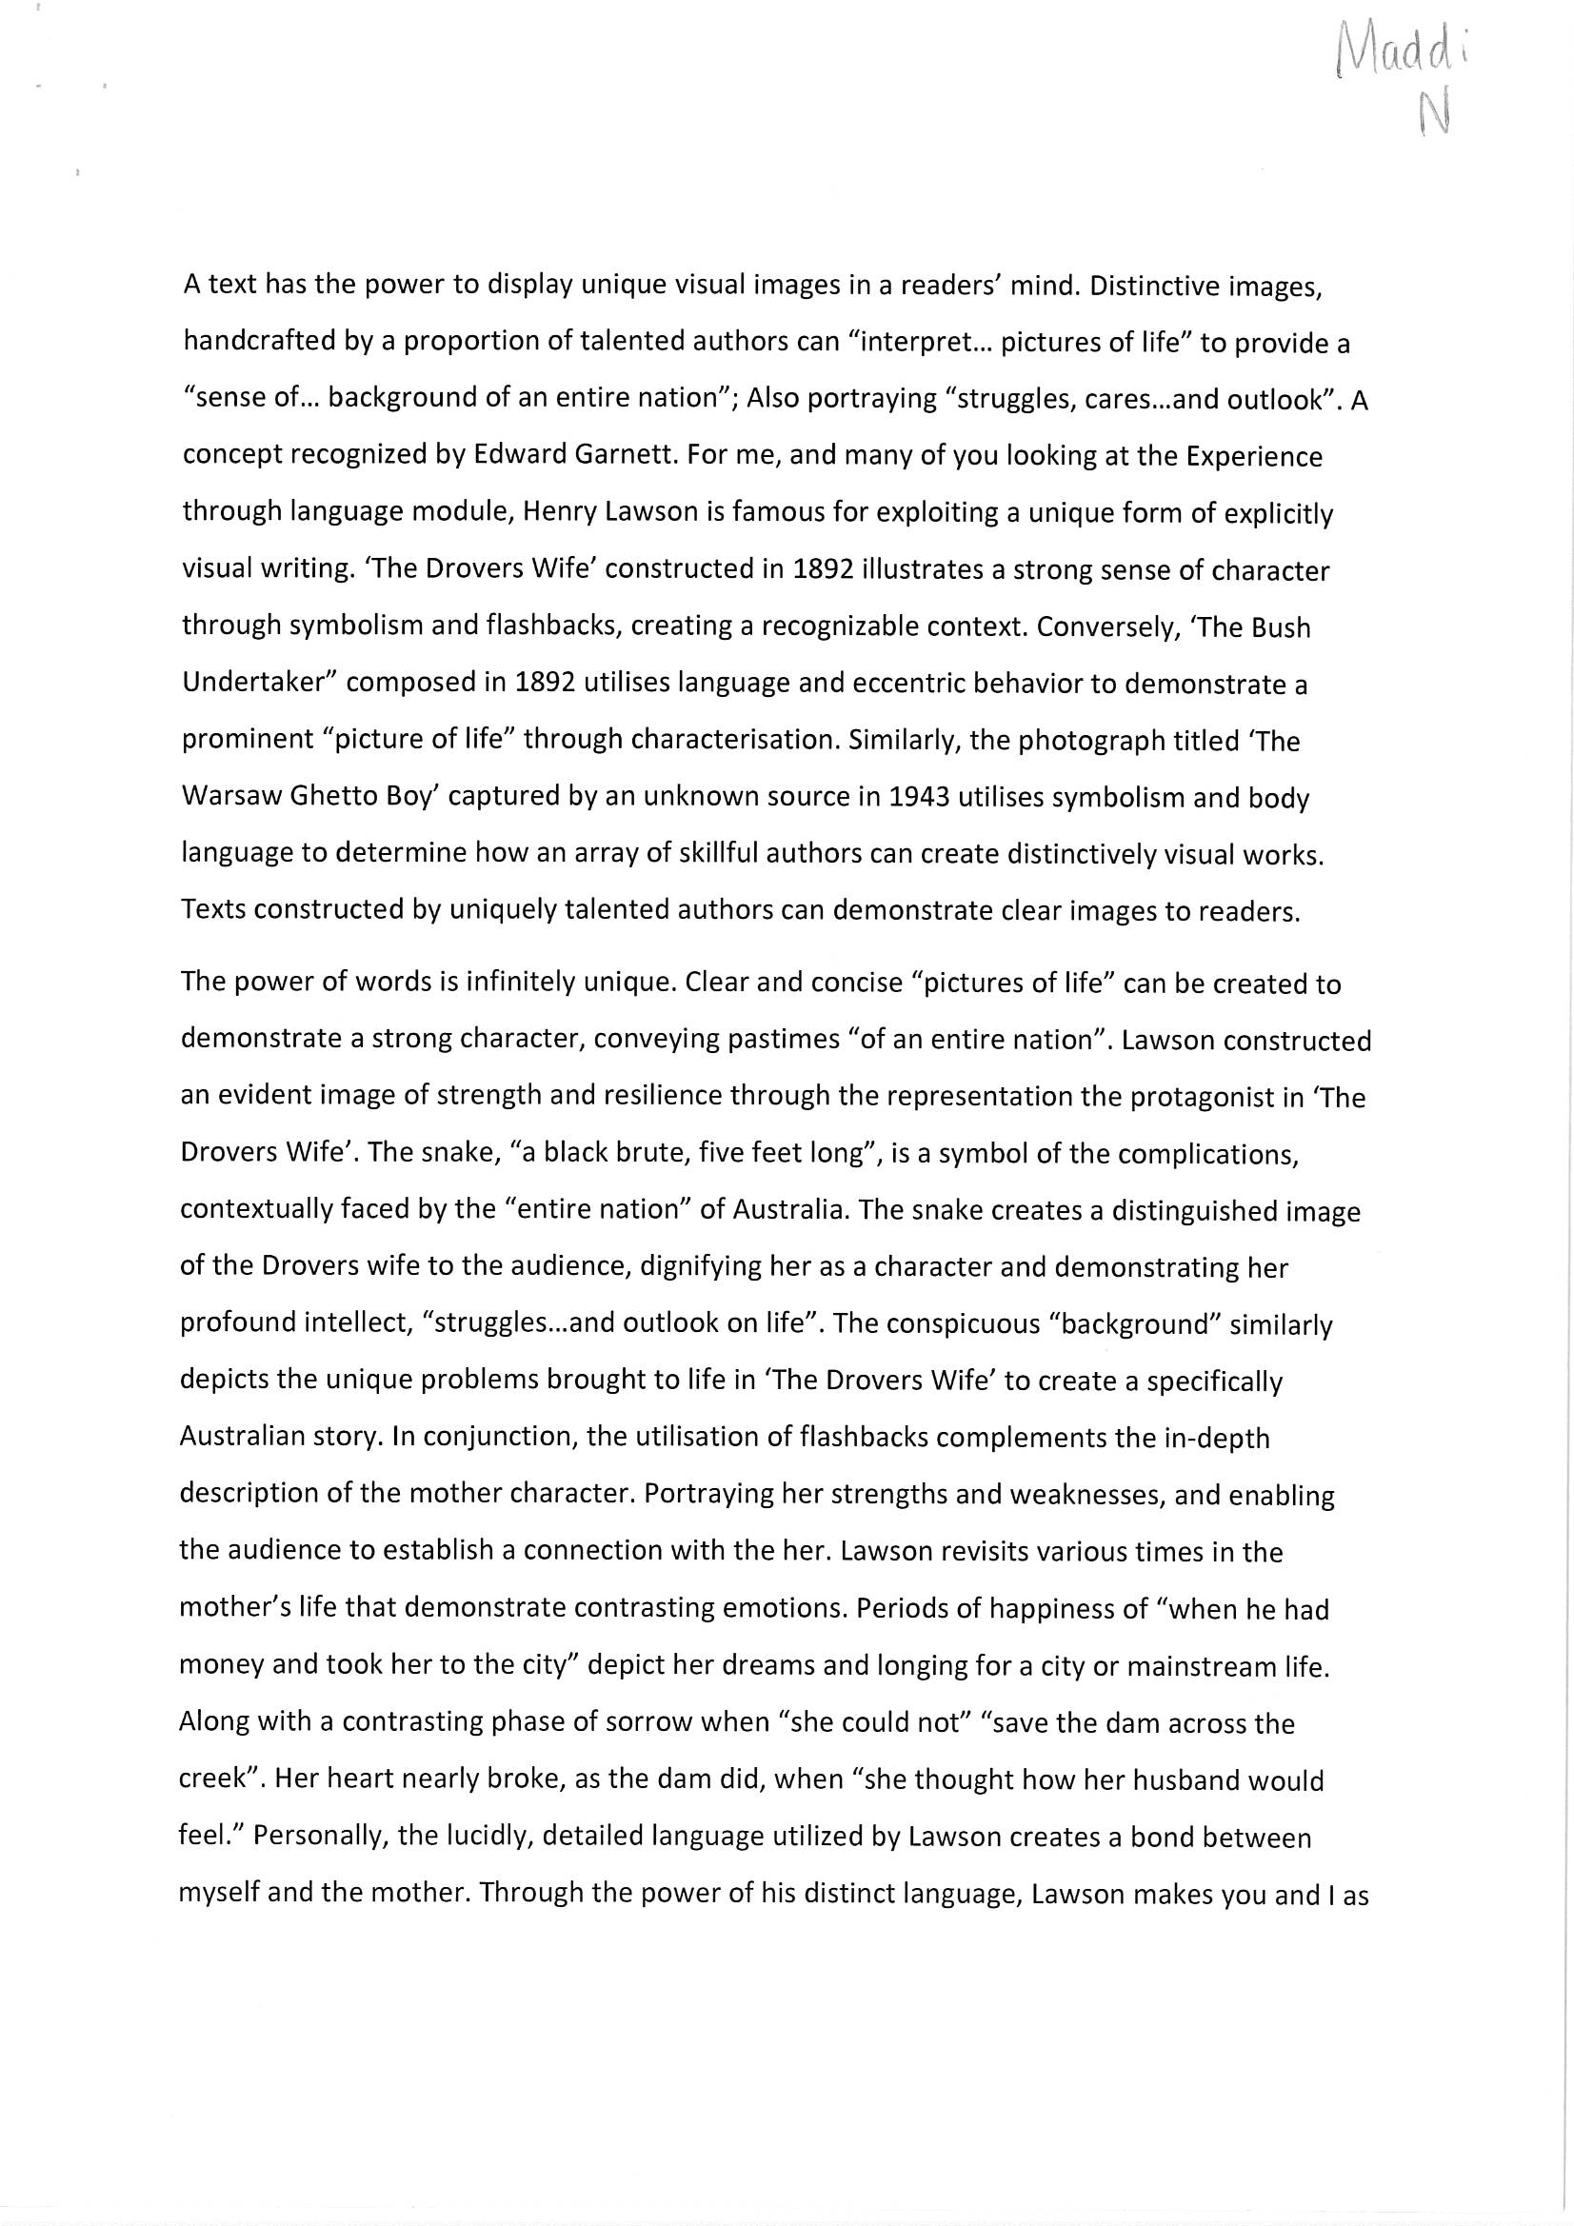
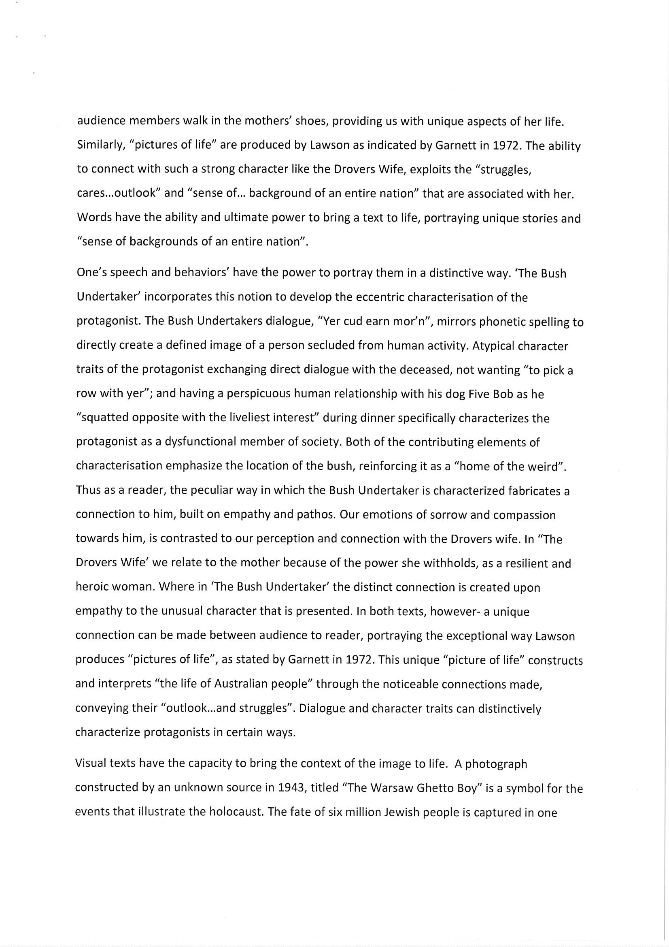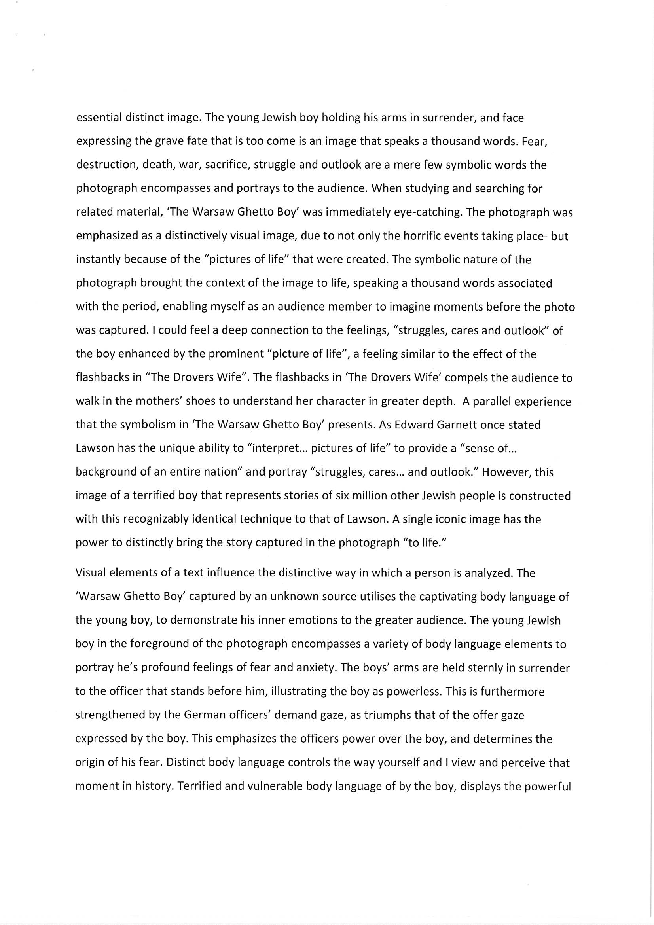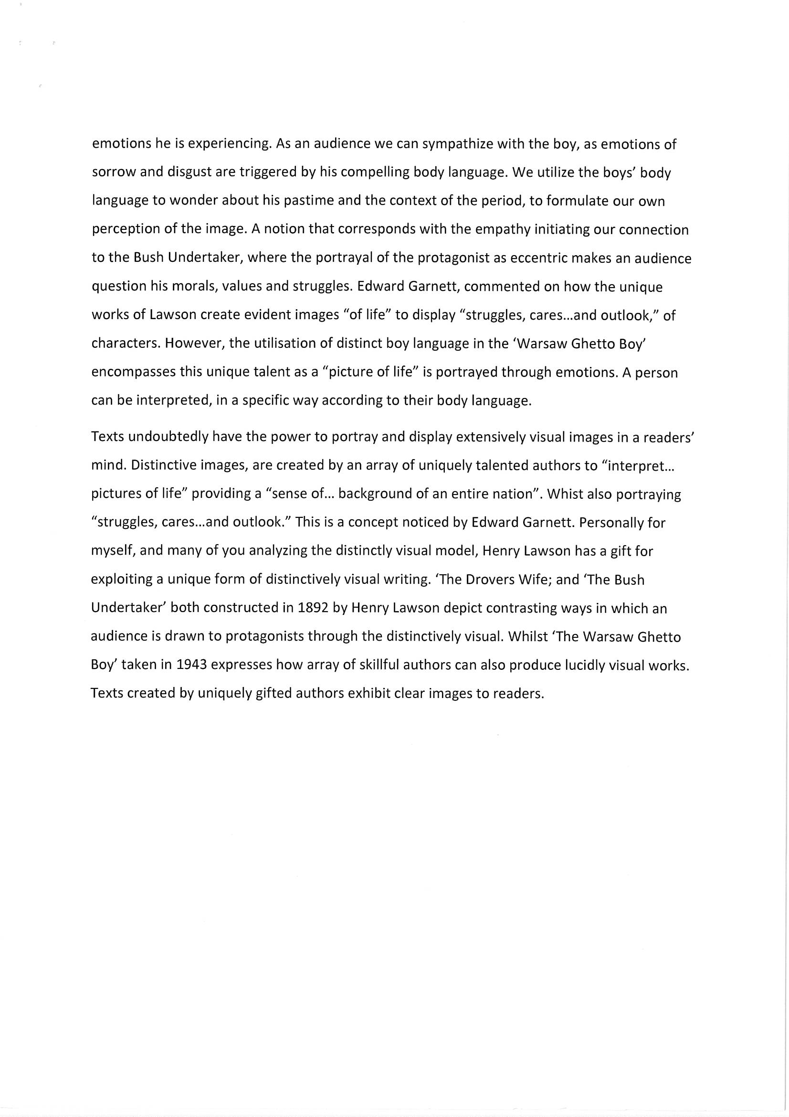

Sample A-Range Response
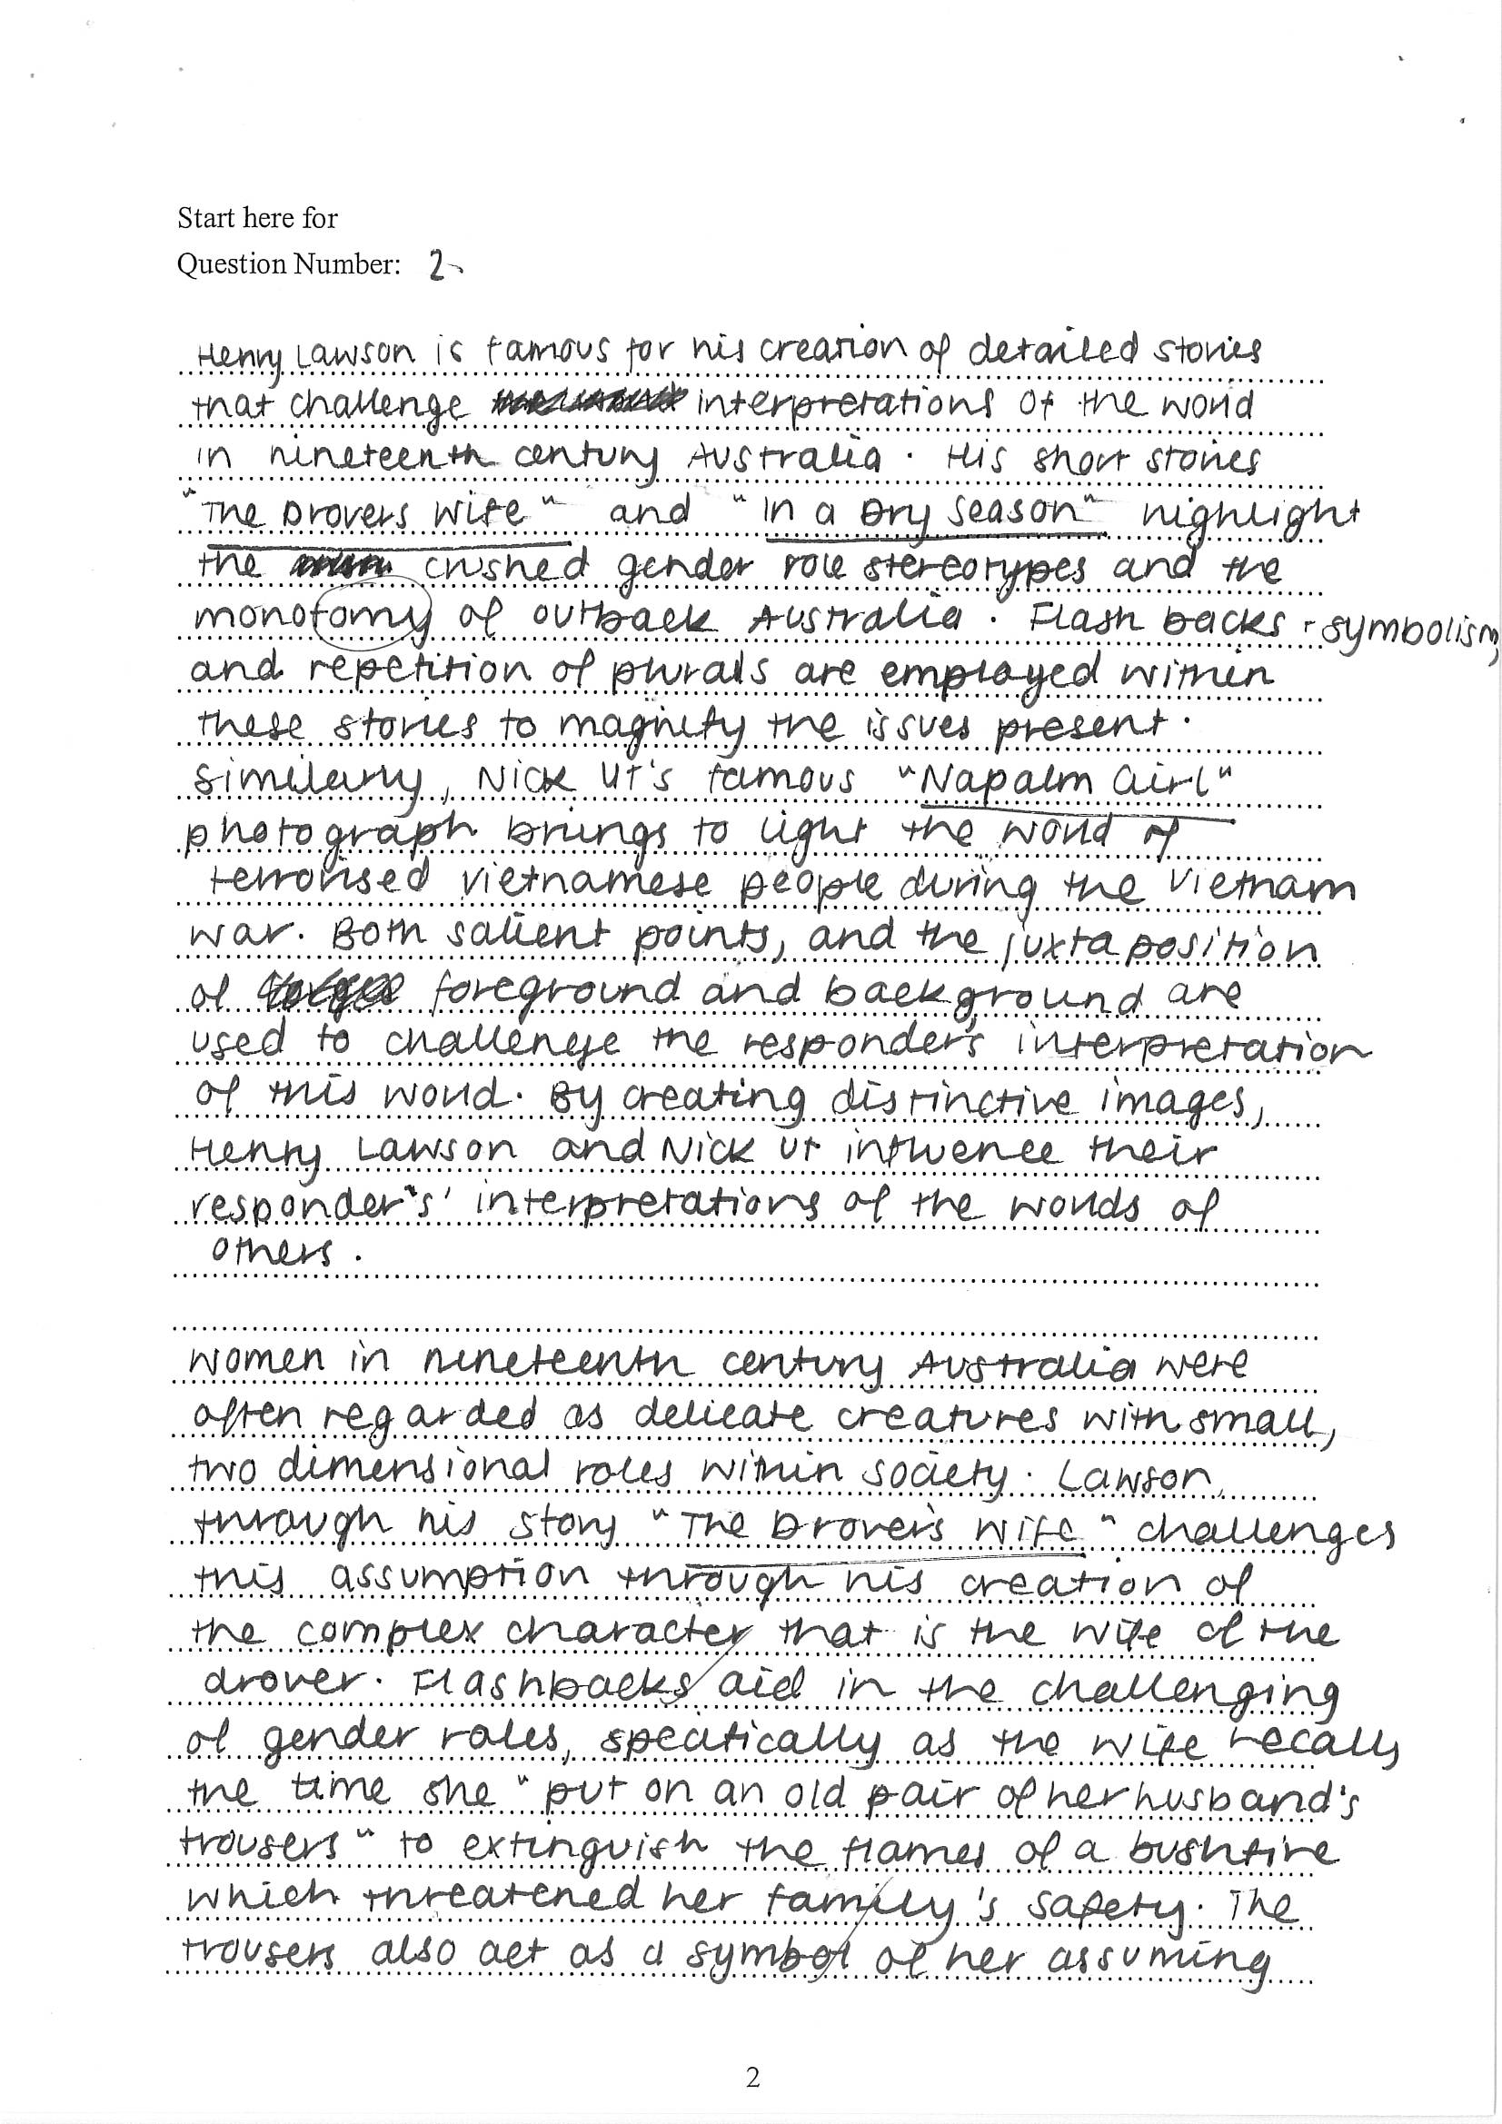
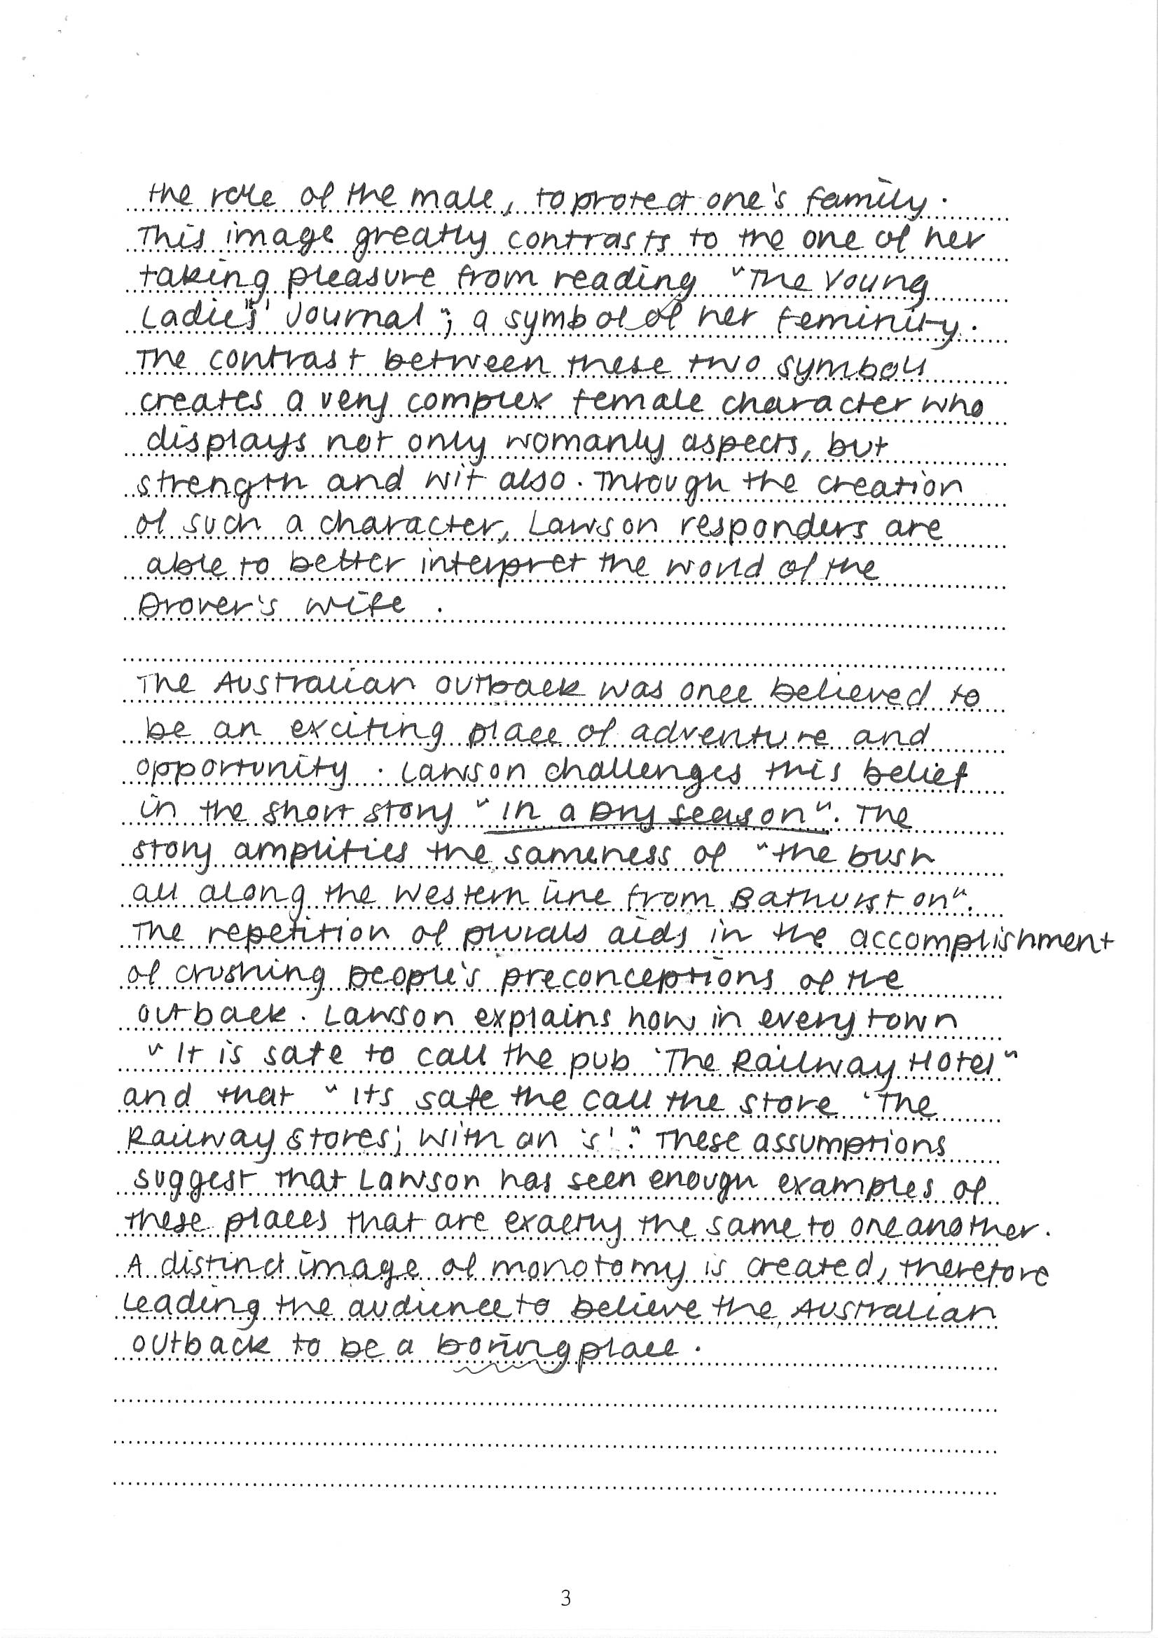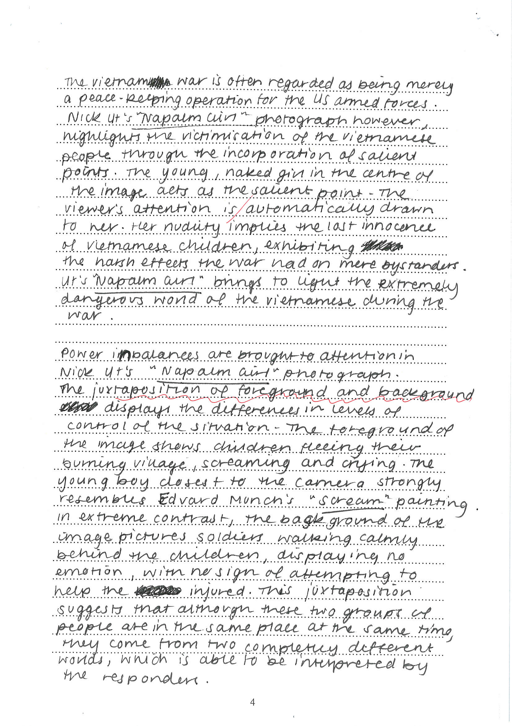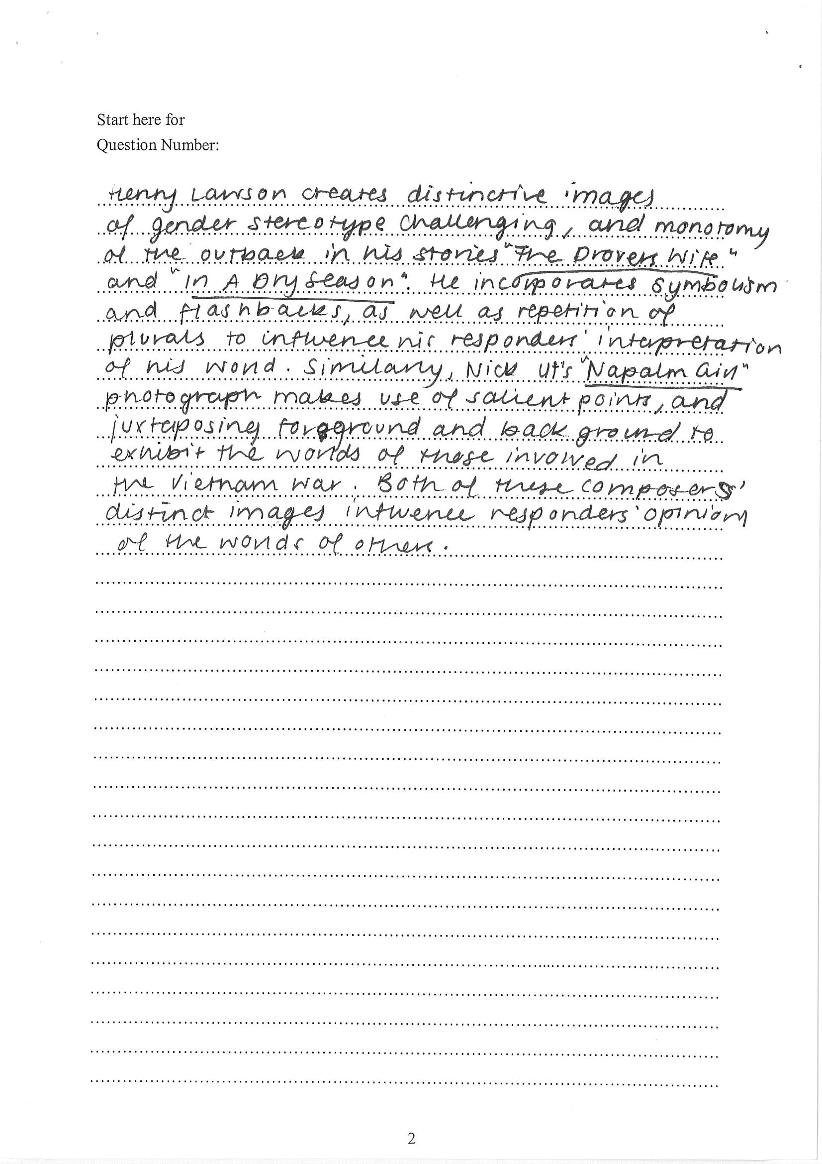
Preparing for your Half-Yearly Examination
Paper 1, Section 1, is worth 15 marks and you have 40 minutes to complete it. That means that you have just over 2 and a half minutes per mark!
Remember that the core concepts of Paper One, Area of Study are:
Representation: | How techniques shape meaning and influence the responses to text.
Perceptions: | How composers and therefore responders see the world. Context shapes this understanding. Characters may be given a voice, marginalised or omitted from the text.
Interrelationships: | Connections between your texts through the concept of Discovery.

How = Techniques
‘How’ is one word, which can be expanded to read explain what language techniques the composer uses to represent belonging in the text. ‘How’ does not, in any way, translate to just copy out something from the included text/s as your response to each section.
To successfully demonstrate your knowledge of how discovery is represented in and through the included texts you will be expected to:
- Know and identify the form (letter, poem, lyrics, web page, extract, and so on)
- Through reading, identify the techniques in written, spoken and visual texts. Identify the one/s which most effectively addresses the question.
- use quotations succinctly, with relevance to the question and to support candidates own analysis
- make detailed reference to the texts including quotations , language forms and features and representations of Discovery.
The technique must be identified in relation to the terminology of the question; describe, explain, compare and contrast, to what extent etc. It is important to correctly address the question.

Text Forms
The texts included in Paper 1: Section I can be in any form. It is important to be familiar with the elements that go together to produce each text. Some forms in past papers have included:

- poems
- song lyrics
- speeches
- articles
- websites
- cartoons/paintings
- comic strips
- excerpts from fiction and non-fiction texts
- reports

There is no way of predicting which textual forms will be included in the paper this year. Students need to have an understanding of a variety of texts forms, which is in keeping with the spirit of the syllabus.

Key Techniques Commonly Found in Particular Text Format
Text format | Language and Visual Techniques commonly found in these types of texts
Poems | Similes, metaphor, personification, alliteration, assonance, rhyme, repetition, onomatopoeia
Song lyrics | As for poems. Repetition and assonance in particular are common techniques
Novels/ autobiographies | As for poems. First ("I"), second ("you") or third ("he/she/it")
Speeches | Repetition, quotations, statistics, alliteration, rhetorical questions, cumulation (lists), imperatives (commands), second person ("you")
Feature articles | Statistics, quotations, passive voice, short paragraphs, words with positive/ negative connotations
Advertisements/ posters | Most salient object, vectors, layout, imperative (command), first person plural ("we"), second person ("you"), cumulation (list), words with positive/ negative connotations, contrast, lighting, camera shots, camera angles, gaze, frontal/ oblique body angles
Cartoons/ comic strips | Exaggeration/ caricature, contrast, body language, facial expressions
Photographs | Most salient object, vectors, contrast, body language, facial expressions, lighting, camera shots, camera angles, gaze, frontal/ oblique body angles
Websites | Most salient object, layout, vectors, hyperlinks, interactive features (games, videos), first person plural ("we"), second person ("you\")

The Last Question in Paper 1 Section I
The final question in Paper 1 Section 1 expects your responses to synthesise the included texts and the knowledge gained as this section is being completed. Recounting responses to earlier questions does not bring together the various elements of the texts.
This final response should have a balance between the number of texts stipulated by the question, historically two. If the weighting of your response is imbalanced this may affect the final mark. Your reponse needs to be 50/50.
To successfully synthesise, compare and contrast between the texts, don’t simply retell or recount. Choose the texts that you are most comfortable with, don’t try and choose one because it might be ‘harder’ and ‘get more marks’ if you do that text.
Direct reference to the texts is essential. Quotations should be appropriate and support the overall response. The common link between the texts is the concept of Discovery. Don’t simply make a brief link at end, almost as an afterthought. Integrate your connections throughout your response.
This question MUST be written as a mini-extended response. An introduction, two body pargraphs and a conclusion.
Past Section I Questions
2016
Text 1: Feature article extract
a) How is the pleasure of discovery revealed in the article? (3 marks)
Text 2: Fiction extract
b) Explain how contrast is used in the text to highlight the child’s discoveries in the museum (3 marks)
Text 3: Poem
c) Explore how imagery is used in the poem to convey the wonder of discovery (3 marks)
Text 4: Fiction extract and Text 1, Text 2 and Text 3
d) Compare the ways unique personal insights into discovery are revealed in Text 4 and ONE other text (6 marks)

2015
Text 1: Short story extract
(a) In what ways is dialogue used to capture the young couple’s reactions to the items they find? (2 marks)
Text 2: Image
(b) How does the image represent an individual who values discovered objects? (2 marks)
Text 3: Poem
(c) Explain how the poem conveys the personal response of the father to his discoveries. (3 marks) Text 4: Nonfiction extract
(d) Analyse how the text portrays the difficulties of discovering ‘what is true and what is false’. (3 marks)
Text 1, Text 2, Text 3 and Text 4: Short story extract, Image, Poem and Nonfiction extract
(e) Compare how TWO of the texts represent the significance of curiosity in the process of discovering. (5 marks)
POETRY- SPAAAMOH

Simile | A simile is when you indirectly compare two unlike things using the words ‘like’ or ‘as’.  The sun looked like a ball of yellow butter.  The snow was as white as cotton wool.
Personification | Personification is when you give an inanimate (non-living) object, human qualities.  The wave’s icy fingers grabbed the surfer.  The alarm clock screamed in my ear.
Adjective | An adjective is a describing word.  The glowing orange sunset fell over the spiky green mountains.
Alliteration | Alliteration is the repetition of a consonant sound in words with close connection.  The slimy snake slithered down the smooth slope.
Assonance | Assonance is the repetition of a vowel sound in words with close connection.  The sound of the hound in the pound upset me.
Adjective | A word naming an attribute of a noun.  It was a sweet, red apple.
Metaphor | A figure of speech in which two things are directly compared.  Her bedroom was a dumpsite.
Metaphor | A metaphor is when you directly compare two unlike things, sometimes using ‘is’ or ‘are’. More powerful than a simile.  The sun is an oven.  The ocean is a giant washing machine.
Onomatopoeia | Onomatopoeia is when an action mimics the sound it makes.  “Bang” “Hiss” “Splash” “Buzz”
Hyperbole | Hyperbole is a form of exaggeration used to highlight a point.  Your bedroom looks like a cyclone’s been through it!

Prose Techniques- LOST FEEJIPS
Level of usage- register | Slang, colloquial (conversational), informal or formal.
Oxymoron | The contradiction between two words in close connection. For example,  “parting is such sweet sorrow”.  “Sometimes we cherish things of little value.”  “ He possessed a cold fire in his eyes.”
Sensory Imagery | Language that is appealing to the senses of the responder.  (SSSTT) Sight = visual imagery, smell = olfactory imagery, sound = aural imagery, touch = tactile imagery, taste = gustatory imagery.
Tone | Tone gives shape and life to literature, because it is through tone that the attitude and mood of a work are created and presented.
Fractured or truncated sentences | Fractured: incomplete sentences that increase tension or urgency or reflect the way people speak to each other.  Truncated sentences: short sentences that increase tension or urgency.
Ellipsis… | A dramatic pause (…). It can create tension or even suggest that there are some words that cannot be spoken.
Emotive Language | Words and phrases that stir the reader’s emotions.
Juxtaposition | The placement of two images (ideas) next to each other to highlight their differences.
Imagery | Vivid pictures are created by words. The reader can be transported to another place and time or visualise a character clearly.
Person | 1st (I or we), 2nd (you) or 3rd (he, she or they)
Symbolism | An object or image that represents something beyond the literal. For example, winter trees might symbolize death, a crucifix might mean sacrifice or a door might be a symbol of entering new worlds. Colour can be used to symbolise love or sadness, happiness or fear.

Visual Techniques- TV FV SCG
Text | The words and phrases that are used.
Vector lines | This refers to the line that our eyes take when we look at a visual. Composers deliberately direct our reading path through the vectors.  The vector lines usually take our eyes to the salient point in the image.
Foreground | Images, text and objects in the front half of the picture.
Background | Images, text and objects in the back half of the picture.
Salient point | The part that your eyes are first drawn to in the visual – visual weighting. Colour, image and layout determine what the salient image is in a visual.
Colour | In a black and white image examine the use of contrast, light and darkness. In a colour image, colours are used to signify feelings and evoke a response. E.g. Red conveys passion, anger, hell, vitality, etc whereas blue conveys peace, harmony or even coldness.
Gaze | Demand Gaze: Where the individuals in the image are looking directly at the audience.  Offer Gaze: Where the individuals in the image are looking away from the audience.

Checklist for your Half-Yearly Examination

- You have written a summary of your own personal definition on the concept of Discovery. You will need this for Section I
- Learn the three acronyms that outline poetry techniques, prose techniques and visual techniques. You can also compile your own list of additional literary and visual techniques to further support your analysis.
- You have completed and marked (with teacher feedback) at least THREE practice reading sections from past paper.
- Complete at least TWO reading section in examination conditions.
- You have written a summary of your own personal definition on the concept of distinctively visual. Ensure that this definition reflects how the distinctively visual is applied in your prescribed and chosen related texts.
- You have completed at least TWO extended response practice questions incorporating your prescribed text and at least one related text. Your responses should analyse the techniques that highlight the distinctively visual in each of your texts. You also need to synthesise between the texts.
- Create summarised study notes on all FOUR short stories and TWO related texts.
- Read through the past HSC questions and write out practice introductions and plans so you feel confident attempting a range of questions. The basic analysis for each response will remain the same, but you MUST shape your response to fit the question. Do not compose a completely prepared answer during your exam – you must specifically and clearly address the question.
- Create study cards on all FOUR short stories and TWO related texts.

